Summit Creek Unit 1B – upper section
Oct 22, 2016
Erin Banwell, FEMO
Jessica Reeves, FEMOt
Arielle Halpern FEMOt
Lacey England, FEMOt
Miller Bailey, FEMOt
Lydia Rumachik, FEMOt

Objectives
Protect existing stands of timber by reducing the timber litter fuels
Encourage return of native grasses by reducing non-native invasive plants

Prescribed Fire Objectives
Safely maintain the prescribed fire within control lines
Reduce grasses, shrubs and timber litter in the project area by 40%-90%
Retain 40%- 90% of the existing oak stands
Limit mortality to conifers > 6” DBH to 20% or less

Topography
Unit 1 – Slopes range from 10% to 60%. Approximately 90% of the area has slopes ranging from 40% to 60%. Devils Gulch riparian area is along the bottom of the west portion. A prominent ridge with a NE/SW orientation bisects ignition units 1A and 1B. Elevation ranges from 2840’ to 3480’. Aspects are NW, W, S, SE.

Project area:
Unit 1 – Unit 1 is divided into ignition units 1A and 1B. The west boundary of unit 1 is bordered by private land, the north and east by the Shasta-Trinity National Forest, and the south is all the Summit Creek Ranch. There is road access into the unit.
Ignition unit 1A: The west control line is a road. All of the ridgeline between ignition units 1A and 1B is accessible to vehicles and Type 6 engines north to the National Forest boundary. There are numerous logging skid trails inside ignition unit 1A and ditch line along portions of the ignition unit 1A and ditch line along portions of the bottom above the west control line.
In ignition unit 1B handline crosses the north boundary down to highway 3. The west control line is shared with ignition unit 1A. Highway 3 is the south control line.

On-site fuels data
Unit 1. The primary fuel models are grass GR1 (60%) and timber litter TL3 (40%). Unit 1 is not grazed by livestock. There are occasional small patches of ceoanothus and manzanita although not enough to change fire behavior over a large area. There are also small and scattered areas of oak woodland with GR1 underneath. Some areas the grass is approximately one foot tall and continuous. Other areas the grass is shorter and not as continuous, broken up by areas with shorter grass and minimal fuel on the ground. Conifer stands are mostly douglas fir with some ponderosa pine on the ridgetop. Very little undergrowth in the timber stands.
Hazards – Numerous snags especially in the oak woodland areas. Smoke impacts to highway 3 along with rolling material impacting the highway. Old barbed wire fencing upright or on the ground.
Concerns – Turn-around time to get water delivered to the project area for holding and mop up. Distance and time to transport injured personnel. Radio communications in the event of an emergency. Smoke impact to residents in Devils Gulch drainage and highway 3. Drought effects to fire behavior/mop up and long term survival of conifers.

Photo Series Comparisons
Aspect: South
Altitude: 3066
Lat./Long.: 40°34.83’, -123°2.51’
Slopes: 0-60%
Stereo Photo Series for Quantifying Natural Fuels; Volume VII.
Burn unit was composed of mixed conifer hardwood and oak savannah components. Species present in the burn unit include:
Quercus garryana
Pinus sabiniana
Psudotuga menzesii
Arcostaphylos spp.
Quercus kelloggii
Arbutus menzesii
Ceanothus cuneatus
Centaurea solstitialis
Quercus vaccinifolia

Minimal presence of
Pinus ponderosa
Pinus lambertiana

Following three photos were taken at the burn unit and compared to Photo Series for Quantifying Natural Fuels Volume VII to assess fuel type, loading, and volume.
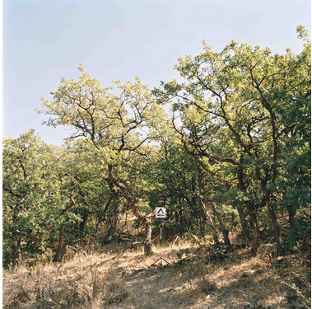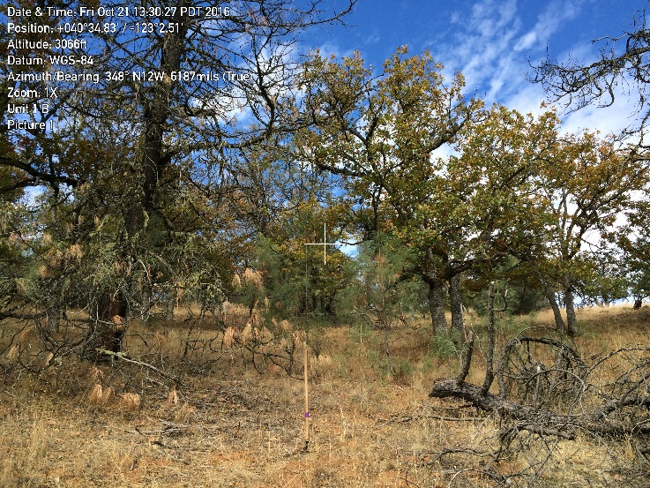
Photo Series, PMS839, NFES 2719, Unit Photo
May 2004, W07
Fuel loading for W07
Litter - 6.4 tons/ac
Duff - 3.4 tons/ac
Total Forest Floor: 9.8 tons/ac

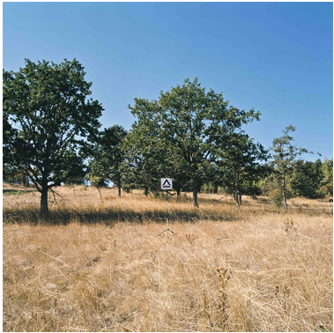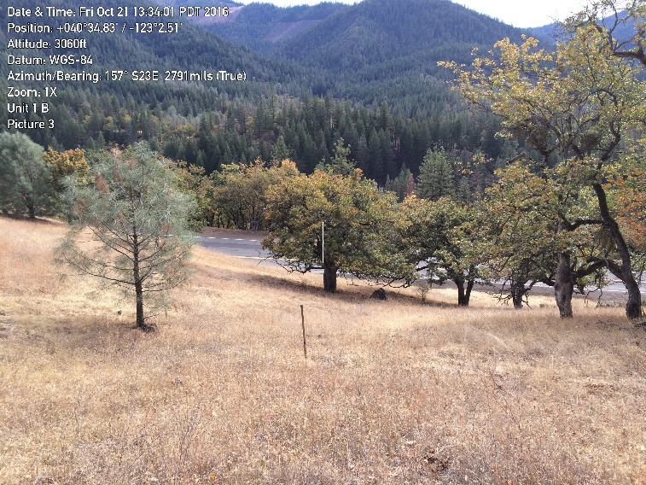
Photo Series, PMS839, NFES 2719, Unit Photo (Photo show unit below treatment unit but fuel
May 2004, W04 types are comparable)
Fuel loading for W04
Litter – 1.6 tons/ac
Duff – 0.1 tons/ac
Total Forest Floor – 1.7 tons/ac

MSC07:
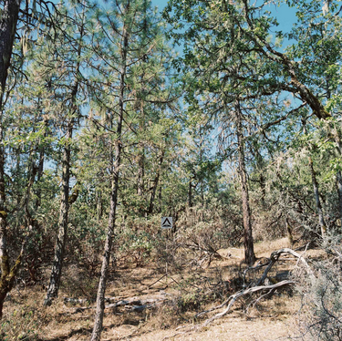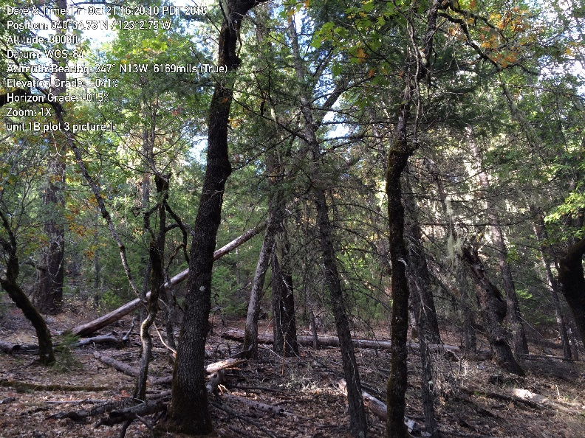
Photo Series, PMS839, NFES 2719, Unit Photo
May 2004, MSC07
Fuel loading for MSC07
Litter – 1.18 tons/ac
Duff – 3.00 tons/ac
Total Forest Floor – 4.18 tons/ac

BlueSky Playground Smoke Emissions and Dispersion Modeling
playground.airfire.org
Model Inputs
A custom fuel model was used to model smoke dispersion and emissions. Fuel loading values were taken from photo series WO 07 Oregon White Oak (Volume VII Western United States Natural Fuel Photo Series 2004). Total sound woody fuel loading was 5 tons/acre. Total above ground fuel loading, not including canopy, was 6.6 tons/acre. And total fuel loading was 23.7 tons/acre. Modeling was done under moist fuel conditions: 10-hr fuels = 12%; 100-hr fuels = 22%; duff = 150%. Ignition time was modeled starting at 1400.

Model Outputs
Consume 3.0 and FEPS were used to model consumption and emissions. The burn consumed 4.8 tons/acre, 3.6 of which were during the flaming phase, 0.9 during smoldering, and 0.3 during the residual phase. Total PM_{2.5} emitted from the burn was 0.81 tons. Total PM₁₀ emitted was 0.96 tons.

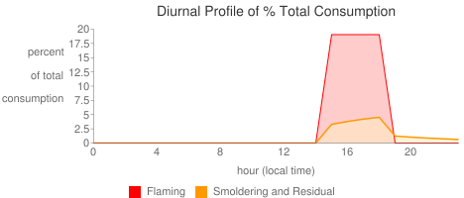
Figure 1. Diurnal Profile of % Total Consumption during the flaming, smoldering, and residual phases of the Summit Creek Unit 1B burn on 10/22/16.

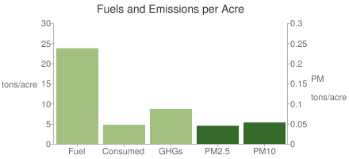
Figure 2. Fuels and Emissions per Acre on the Summit Creek Unit 1B burn on 10/22/16.

The HYSPLIT smoke dispersion model was run using CA/NV forecast zone for 10/22-23/16. Results are shown in Figure 3 below and described in the Smoke Observations section of this report. Compared with real-time smoke observations, the model results were fairly accurate.
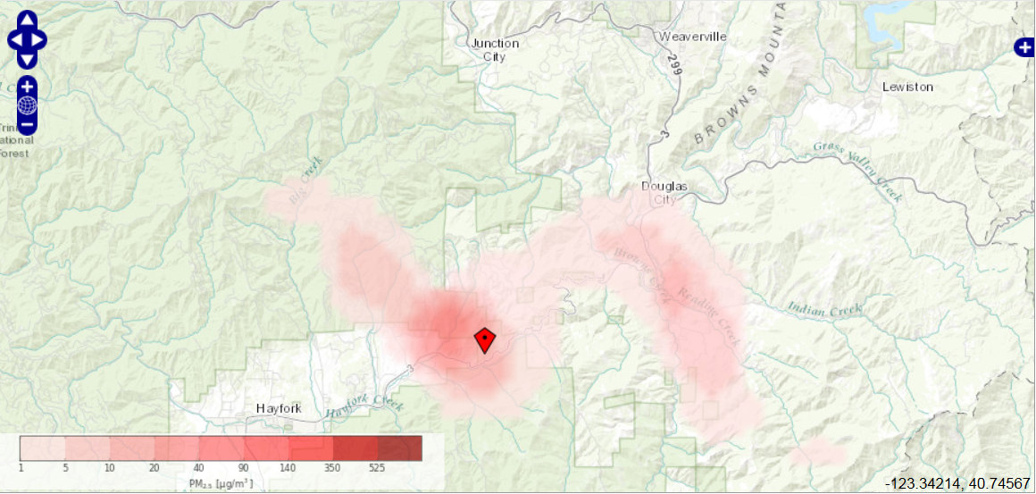
Figure 3. HYSPLIT modeling results for 10/22/16 on the Summit Creek Unit 1B burn .

Fire Weather Summary
Time | Location | Elevation | Aspect | Wind Direction | Wind Speed | Gusts | Dry Bulb | Wet Bulb | Relative Humidity | FDFM (exp) | FDFM (sh) | POI (exp) | POI (sh)
1030 | Between DP5 and 6 | 3200 | S | SE | 1-3 | n/a | 46 | 45 | 93 |  | 17 |  | 10
1100 | Staging area | 2950 | S | S | 2-3 | n/a | 49 | 46 | 81 | 13 | 15 | 20 | 10
1200 | Staging area | 2950 | S | S | 0-3 | 7 | 54 | 49 | 71 | 10 | 12 | 30 | 20
1300 | Staging area | 2950 | S | S | 0-3 | n/a | 56 |  | 67 | 13 | 13 | 30 | 20
1415 | Test fire | 3389 | S | SW | light | n/a | 65 | 53 | 46 | 8 | 11 | 40 | 20
1510 | Burn unit below fire | 3276 | S | SSW | light | n/a | 66 | 50 | 31 | 6 | 9 | 50 | 30
1600 | Burn unit below fire | 3206 | S | WSW | 1-3 | 5 | 64 | 49 | 33 | 7 | 9 | 50 | 30
1700 | Just below two-track road | 3146 | S | E | 1-3 | 5 | 63 | 49 | 36 | 8 | 10 | 40 | 30
1800 | Just below two-track road | 3146 | S | n/a | n/a | n/a | 57 | 49 | 57 | 13 | 13 | 20 | 20
Temperature ranged from 46 to 66 F, while RH ranged from 31 to 93%. Maximum probability of ignition was 50%. Wind direction was variable, ranging from 0 to 3 mi/hr, with gusts to 7 mi/hr around 1200. Weather observations collected by Aisha Wiig.
Table 1. Weather observations for Summit Creek burn, Oct 22, 2016.

Smoke Summary
Smoke observations collected by Lydia Rumachik.
Table 2. Smoke observations for Summit Creek burn, Oct 22, 2016.
Time | Location/elevation | Wind speed and direction | Elevation of smoke column above ground | Smoke column direction | Other observations
1500 | Up ridge line to the north | S 0-3mph | 530’ | NE | Shear, wispy, white, blowing NE, no inversion
1525 | 40⁰ 35.16 X 123⁰ 2.25 / 3200’ | S 0-3mph | 550’ | NE | No inversion, shear to the NE
1537 | 40⁰ 35.19 X 123⁰ 2.15 / 3200’ | S 0-3mph |  | N - NE | Very wispy, no defined column, no inversion
1556 | 40⁰ 34.76 X 123⁰ 2.59 / 3000’ | S 0-3mph |  | E | Light and wispy, pushing E, high level cloudiness moved over fire
1610 | 40⁰ 35.53 X 123⁰ 1.33 / 3400’ | SW 0-3mph |  | E | Wispy column, good lift, shearing E
1625 | 40⁰ 35.43 X 123⁰ 1.12 / 3400’ | SW 0-3mph |  | Upright | Brown, wispy, good lift, shearing to NE
1644 | 40⁰ 35.45 X 123⁰ 1.10 / 3400’ | SW 0-3mph | At tree level | Upright, shearing NE | Brown, wispy, starting to drop, defined column at tree line
1700 | 40⁰ 35.45 X 123⁰ 1.10 / 3400’ | SW 0-3mph | At tree level | Flattening to the NE | Column dropping lower under high level clouds, decreasing in altitude, brown, wispy, shearing E
1720 | 40⁰ 34.89 X 123⁰ 2.20 / 2990’ | SW 0-3mph | At tree level | Shifting SW | Smoke settling in the valley, wispy, significant dispersal
Timeline of Major Events
1100 On-site briefing
1200 Resources begin to engage in prep activities for the burn
1435 Test fire; successful; continue ignitions
1450 Pause in ignitions to assess fuel conditions
1500 Continue ignitions
1725 Ignitions complete
1830 On-site AAR

Spot Weather Forecast
.DISCUSSION...
CLOUDS WILL GRADUALLY DISSIPATE TONIGHT AS A WEAK FRONT PASSES
THROUGH, FOLLOWED BY DRYING ALOFT THAT SHOULD RESULT IN A SLIGHTLY
COOLER NIGHT THAN THE PREVIOUS NIGHT. WHILE A WIDESPREAD FREEZE
IS NOT ANTICIPATED...SOME OF THE LOWER ELEVATIONS NEAR HAYFORK COULD
SEE SOME PATCHY FROST WHERE TEMPERATURES DIP INTO THE MID 30S.
WINDS ARE EXPECTED TO BE LIGHT AND DOWNVALLEY.
FOR TOMORROW, WHILE TEMPERATURES WILL LIKELY BE A FEW DEGREES
COOLER THAN YESTERDAY, DRIER AIR SHOULD YIELD LOWER AFTERNOON
HUMIDITY VALUES AND CLEARER SKIES, WITH INCREASING HIGH LEVEL
CLOUDINESS LATE IN THE DAY. EXPECT LIGHT TERRAIN DOMINATED WINDS
TO BECOME UPVALLEY BY EARLY TO MID AFTERNOON.
AN APPROACHING COLD FRONT WILL RESULT IN INCREASED CLOUDINESS,
SLIGHTLY COOLER TEMPERATURES, AND BREEZY SOUTHEAST WINDS IN
EXPOSED AREAS SUNDAY.

.TONIGHT...
MIN TEMPERATURE.....35 TO 38.
LAL.................1.
MIXING HEIGHT.......2600 FT AGL DECREASING TO 300-500 FT AGL LATE
IN THE EVENING.
MAX HUMIDITY........85 TO 95 PERCENT.
SKY/WEATHER.........MOSTLY CLOUDY THEN BECOMING MOSTLY CLEAR.
CWR.................0 PERCENT.
WIND (20 FT)........WEST WINDS 5 TO 8 MPH IN THE EVENING...BECOMING
LIGHT DOWNVALLEY WIND.
TRANSPORT WINDS.....WEST 11 MPH BECOMING LIGHT AND VARIABLE.

.SATURDAY...
TIME PDTTEMPRH%WIND MPH
09003890DOWNSLOPE 1-4
11004568DOWNSLOPE 1-4
13005744SW OR UPSLOPE 2-5
15006830SW OR UPSLOPE 3-5 G 9
17006630SW OR UPSLOPE 3-5 G 9
19005845W 2-4
LAL.................1.
MIXING HEIGHT.......500 FT AGL INCREASING TO 4700 FT AGL BY MID AFTERNOON
MIN HUMIDITY........24 PERCENT.
SKY/WEATHER.........PARTLY CLOUDY THEN BECOMING SUNNY.
CWR.................0 PERCENT.
TRANSPORT WINDS.....SOUTHWEST 5 MPH.

.SATURDAY NIGHT...
MIN TEMPERATURE.....37 TO 40.
LAL.................1.
MIXING HEIGHT.......300-1400 FT AGL.
MAX HUMIDITY........75 TO 85 PERCENT.
SKY/WEATHER.........PARTLY CLOUDY.
CWR.................0 PERCENT.
WIND (20 FT)........DOWNVALLEY 2 TO 5 MPH.
TRANSPORT WINDS.....WEST 5 MPH.

.SUNDAY...
MAX TEMPERATURE.....60 TO 63.
LAL.................1.
MIXING HEIGHT.......800 FT AGL INCREASING TO 4000 FT AGL LATE IN
THE AFTERNOON.
MIN HUMIDITY........35 TO 45 PERCENT.
SKY/WEATHER.........MOSTLY CLOUDY.
CWR.................0 PERCENT.
WIND (20 FT)........SOUTHEAST WINDS INCREASING TO 5 MPH WITH GUSTS TO 10 MPH.
TRANSPORT WINDS.....SOUTHEAST INCREASING TO 10 MPH.

