RX-300 Unit 15: Meeting Objectives with RX Job Aid

# Ignition TOOLS for Meeting Objectives

|  |  |
| --- | --- |
| Condition | Suggested tool |
| * Small to medium fire area * Values at risk near the line * Complex unit share | * Drip torch * Fusee |
| * Steep terrain interior * Flashy fuels interior * Desire to reduce fire behavior interior | * Flare launcher * Fusee * Chucker * Pyro shot |
| * Perimeter ignition for a large fire area near the road | * Terra torch |
| * Interior ignition for a large fire area | * PSD – helicopter or UAV * Helitorch |
| * Piles | * Drip torch * Chucker * Propane torch * Fire gel |

# Ignition PATTERNS for Meeting Objectives

|  |  |  |  |  |  |  |  |  |
| --- | --- | --- | --- | --- | --- | --- | --- | --- |
| **Pattern** | **Graphic** | **Description** | **Example Objective** | **Residence time** | **Fire intensity** | **Fuel use** | **Effort** | **Time** |
| **Backfire** |  | Lighting the windward side and letting the fire move into the wind. Used in black lining. | Reduce the thatch in the dominant grass | High | Low | Low | Low | High |
| **Strip head fire** |  | Continuous strips of ignition parallel to the wind at set spacing and stagger with the intent for the strips to come together. | Limit mortality in the overstory trees while increasing mortality in the understory trees | Mod/High | Mod/High | High | High | Mod |
| **Dot fire** |  | Dots of ignition at set intervals with the intent for the dots to come together | Reduce the intensity of a strip head fire during drier fuel conditions. | Mod | Low/Mod | Low/Mod | Mod/High | Mod |
| **Pattern** | **Graphic** | **Description** | **Example Objective** | **Residence time** | **Fire intensity** | **Fuel use** | **Effort** | **Time** |
| **Flank fire** |  | Continuous strips of ignition moving into the wind at set spacing, forming chevrons on topography. | Limit mortality in the overstory trees while increasing mortality in the understory trees AND decreasing the time to completion. | Mod | Mod | Mod | Mod | Low/Mod |
| **Centerfire** |  | Ignition starts from the center, often on elevated topography. Concentric circles of ignition around the center. | Increase smoke lift and limit vegetation and animal mortality | Mod/High | Low/Mod | Mod | Mod | Mod |
| **Ring fire** |  | Ignition around all sides of the perimeter with fire burning inward. | Increase smoke life and increase vegetation mortality | Mod | High | Low | Low | Low |
| **Jack potting** |  | Dots of ignition in receptive fuel without the intent for the dots to come together | Consume available fuel and fuel use on non-available areas. | Low | Mod | Low | Mod | Mod |

**Ignition TECHNIQUES for Meeting Objectives**

|  |  |  |  |
| --- | --- | --- | --- |
| Tool | Description | Build MORE heat | Build LESS heat |
| **Pattern** | * Strip head * Flank * Dot * Ring * Jackpot | * Strip head * Ring | * Flank * Dot |
| **Number** | * Number of lighters | * More lighters | * Fewer lighters |
| **Spacing** | * Space between lighters | * Wet? Less spacing * Dry? More spacing | * Wet? More spacing * Dry? Less spacing |
| **Stagger** | * The angle or time from one lighter to another | * Flatter angle or less timing between lighters | * Steeper angle or more time between lighters |
| **Speed** | * How fast the lighters move | * Faster lighters | * Slower lighters |
| **STOP/Pause** | If you are not meeting objectives after adjusting ignition – consider STOPing or pausing ignition | | |

# Fire Applications to Meet Objectives

LOW - - - - - - - - - - - - - - - - - - - - - - - - - - - - - - - - - - - - - - - - - - - --HIGH

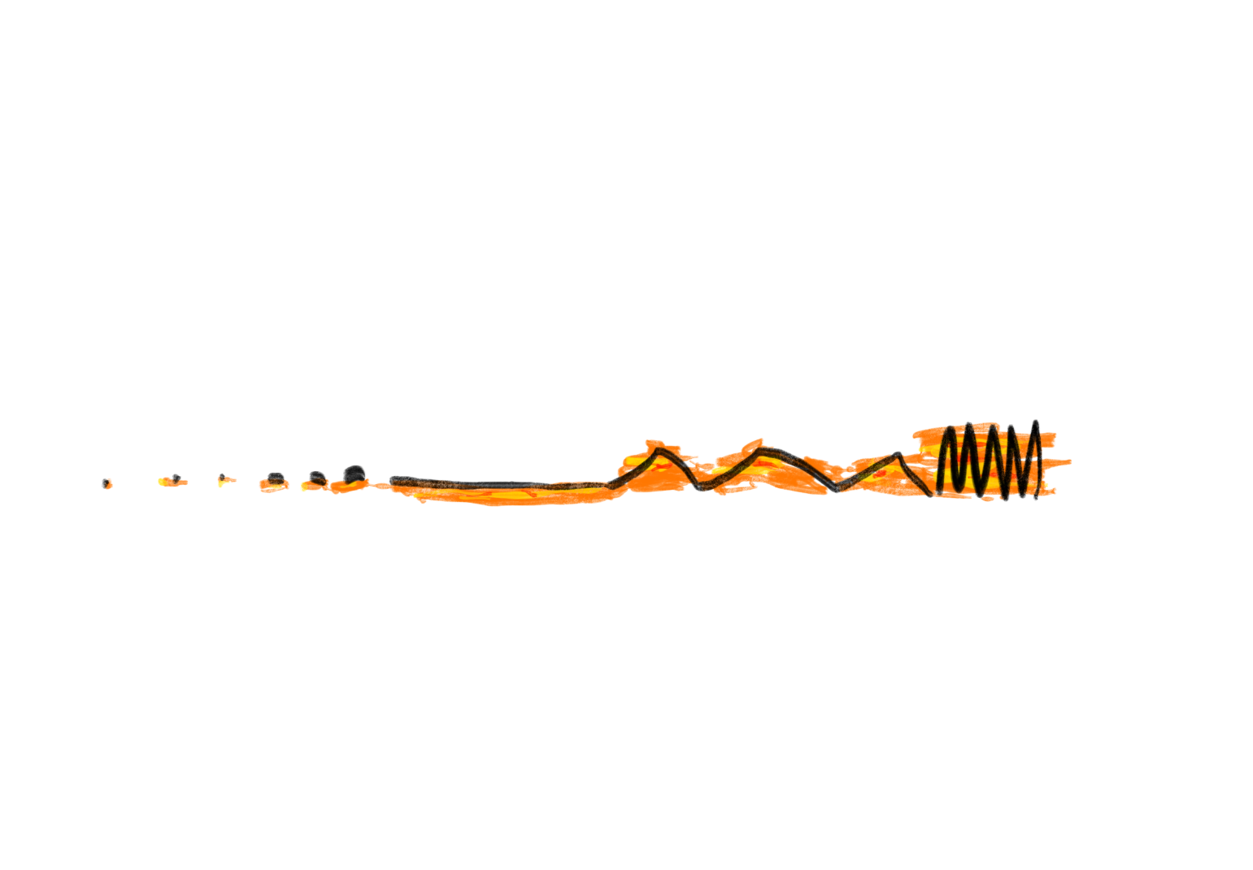

**Intensity**

**Consumption**

**Fuel Use**

**Effort**