RX-300 Unit 14: Fire Weather Job Aid
Last updated: 12/06/2022
These resources can be helpful for both prescribed fires and wildfires. Fire weather resources and the instructions on how to use them change regularly. Tips for finding the latest resources:
- Conduct a web search for keywords
  - Community of practice for fire - https://usdagcc.sharepoint.com/sites/fs-spf-fht
- Check your local weather service or GACC predictive services page for fire weather resources
  - Ex. Weather, Fuels, and Fire Danger, Outlooks
- Contact meteorologists – consider inviting and IMET to your area
- Check for updated training on the Wildland Fire Learning Portal
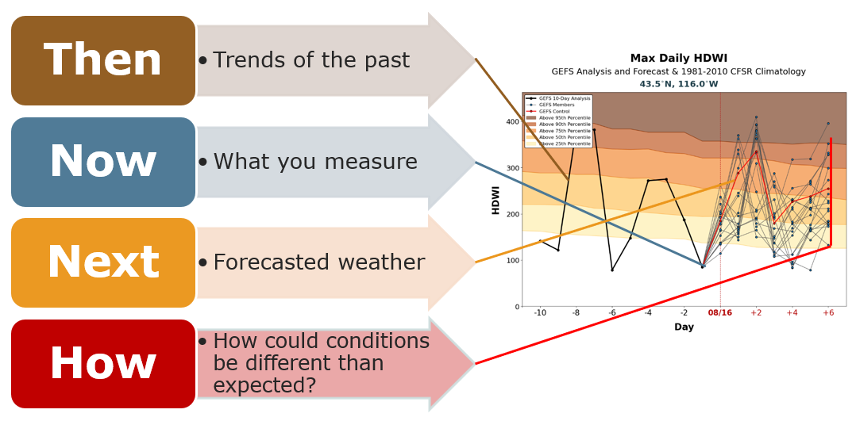

Then
- FEMS – Fire Environment Mapping System (coming soon)
- FireFamilyPlus
  - FireFamilyPlus Video Series
- Local RX atlas – Keeping records of previous burns can help you understand the conditions that have led to successful or unsuccessful burns in the past (example Turnbull RX Atlas).
- Local experience – This is the least reliable but is helpful to confirm what you see in the data.
- Weather Underground - search for an area and click on the history tab
- Enterprise Geospatial Portal (EGP)
- NBM 1D Viewer – Select your RAWS. See how the forecasted conditions aligned with the observed conditions in the past.

Now
- Kestrel and/or Sling – calibrate them – make sure they are used correctly. Kestrels vs. Sling
  - SFE Webinar: An Assessment of Temperature and RH from a Variety of Weather Meters
- Stationary RAWS – pick one that is representative – See Getting Started with FFP for tips on picking a RAWS
- Portable RAWS – place in an areas near your burn or in a representative location.
  - Prescribed Burn Portable RAWS
- Data logger – Kestrel DROP or other brands where you can place many small devices around the burn unit.
- Clearing index - Air Quality/Smoke Dispersal Index used to regulate open burning
- AirNOW

Next and How
VIDEO: Guide to Fire Weather Forecasts
- Meteorologist – build a relationship with your local weather service. Invite them to your area to see conditions on the ground. Collect information that will help their modeling. The USFS has the ability to order an IMET for High Complexity Prescribed Fires or in some cases the servicing NWS office may suggest IMET support for those locations that have a history of inconsistent or challenging forecast accuracy. Coordinate with your Fuels Lead when there is a need.
- Fire Weather Dashboard
  - How to use the Fire Weather Dashboard
- Windy.com – App and Computer
- Weather Underground – App and Computer
- Zoom EARTH
- Venusky
- Hot Dry Windy
- US Drought Monitor
- RMA Dashboard
- WFAS – Wildland Fire Assessment Tool
- www.weather.gov/spot - Spot Weather
  - Build a relationship with the local representatives for the National Weather Service
  - Collect representative weather observations. 3 observations, 1 hour apart.
  - Give feedback on the relationship between forecasted weather and observed weather.
  - On the burn day – contact the local NWS office. Ask for a fire meteorologist if on duty, and see if there have been any changes to the forecast.
- AirNOW

