Photoload Quick Reference Guide

The Big Picture - Photoload is a samling technique used to estimate the fuel loading by comparing what you see on the ground to a series of pictures of fuelbeds that have had their fuel loading measured.

10hr.
0.25-1”
100hr. 1-3”
What’s it mean? Amount of time it takes to get the moisture of the fuel close to the moisture in the air.
1hr.
0-0.25”
Terms
DWD – Down Dead Woody Fuel is material that is dead, downed and woody. This does not include litter, pinecones, bark, stalks of herbaceous material, or woody material that is not on the ground.

Herbaceous – vegetation that is not woody. Includes grasses, sedges, and forbs. Does NOT include shrubs and trees

Surface fuels - biomass<6 feet. Fuels >6 feet are canopy fuels and not considered in photoload.

Overview of steps to perform photoload
- Set microplot frame
- Measure average duff and litter depth and multiply by bulk density to get loading
  - Duff = inches *10 tons/acre/inch
  - Litter = inches * 5 tons/acre/inch
- Visually estimate loading for 1 and 10-hour fuels
  - Select the picture that just over represents and adjust loading down as needed
- Visually estimate loading for 100-hour fuels and adjust for weight of 1 and 3 in. particles. Multiply the loading by the decay adjustment as necessary
  - 1 inch = Reference weight / 3
  - 3 inch = Reference weight * 3
- Visually estimate loading for shrub and herbaceous and adjust for height
  - Plot height/reference height = Adjustment factor
  - Adjustment factor * loading from sequence = loading for plot
- Calculate loading for 1000+ hour fuels (logs) in a 10X10 meter plot or 5.6 meter (18.4 ft) radius plot. Portions of logs outside this area do not count.
  - Plot method – measure or estimate the total length and average diameter for all logs
  - Log method – measure or estimate the length and average diameter for individual logs and add all logs together

Tips for success
  - Use your head – before writing down your numbers, check it to make sure it makes sense, then check it again.
  - Watch your decimals – this is the mostly likely way for you to create very large errors in your data.
  - Bring a friend – it is helpful to bounce thoughts and numbers off each other.
  - Practice, Practice, Practice!
Rules to remember
- Fuel particles outside the plot frame do not count in your estimate.
- DWD material covered by litter is considered litter and not counted in DWD estimates.
- Rotten logs are considered litter when…
  - It is no longer in the shape of a log
  - The long, center axis of the log is below the top of the litter
- A log with a decay class of 5 has roughly half the loading of a sound log that is the same size.
- Odd-shaped pieces can be mentally formed into a circle to get their diameter and put in fuel class.
- To get the average height of your shrub and herbaceous, imagine a sheet draped over the plot and estimate the average height of the sheet. (use your leg as a ruler)
- A shrub sequence can calculate the load for seedlings and saplings with vegetation below 6 feet.
- If a tree > 6 ft tall is within your plot frame, consider moving the frame and documenting the new location.
- The best time to sample is after green-up.
- If your herbaceous fuel is dead, then estimate loading as though the dead leaves and stems were live

Approach – choose your approach based on your objectives and the time you have. Become proficient in the microplot approach before using other approaches.
More
- Microplot approach– 1 m X 1 m plot frame is placed on the ground in either a random location or a fixed location determined by a sample design. The 1, 10, 100, herbs, and shrubs are measured at this level. 1000-hour fuels are measured at the 10X10 meter level (18.4 ft. radius).

- Macroplot approach– usually 10th acre circle (37.2 ft. radius) or square. The size of the microplot can vary but remember – you need to know the size of the area you are sampling in to scale up.
- Visually divide the macroplot into areas with more obvious differences in loading.
- Estimate the proportion for each of those areas
Accuracy & Effort
- Estimate the loading for each division and calculate the weighted average by area of the loading.
- Stand approach - Do a walk through the entire stand to determine approximate loadings
  - Visually divide the stand into areas that reflect noticeable fuel loading differences and record on map if there is time. One loading for the entire stand is good, but making several estimates is better.
  - Estimate the proportion of those divisions to the entire stand area.
  - Estimate the loading for each division and calculate the weighted average by area of the loading.
Less
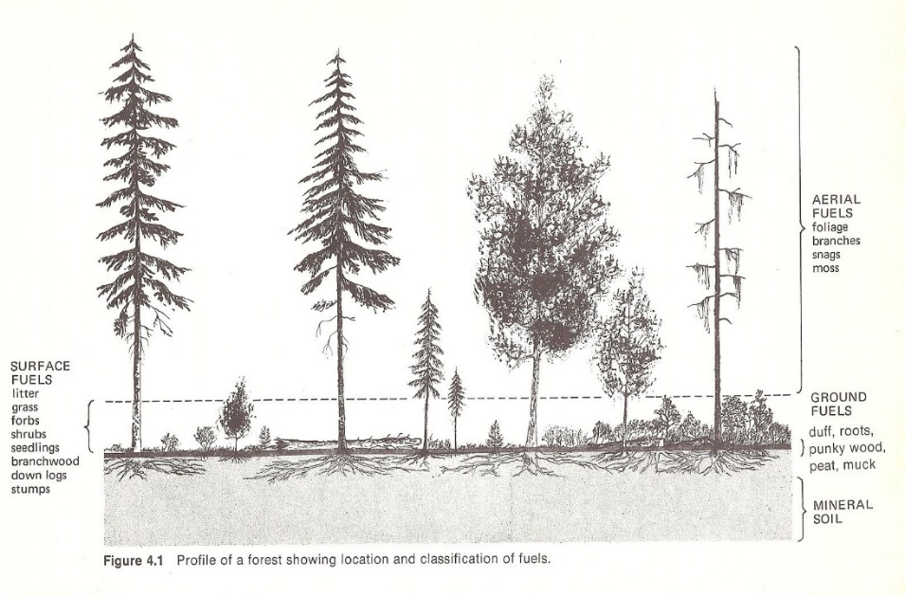
- Eye-ball approach – although not at all a form of fuel load measuring, after getting experience with the photoload method, you will be able to have a general concept for the loading by simply walking around on the site and evaluating the photoload sequences to see what picture best represents the loadings
Pyne et al.
Feel like the photoload sequences do not match your fuels? Make your own! See GTR 416: Creating a photographic loading sequence
Photoload happens here

