Malheur National Forest
Emigrant Creek Ranger District
Fire Effects Monitoring Report

Unit: Dairy Unit 103 Date: September 29 - October 9, 2016

Fuel Type: Dry ponderosa pine, bitterbrush, timber litter, grass FEMO: Neil Dresser
Fuel Model: 9, 2 FEMO (t): Kayla Johnston
Acres Planned: 3,550
Acres Burned: 1,475

Purpose and Resource Management Goals:
The primary purpose of this prescribed burn was to mimic historical frequent, low-intensity fire in order to reduce fuel loads; restore the dry ponderosa pine ecosystem to more natural, healthy stand densities; and to remove excess forest floor litter and materials to facilitate natural seedling establishment. This prescribed burn was also a step in the long term goal of maintaining the site with intermittent fire and moving the site towards Condition Class 1.

Specific Prescribed Fire Objectives:
- Burn 40-90% of the unit - Achieved 90%
- Reduce 1 hr. fuels by 40-90% - Achieved 70%
- Reduce 10 and 100hr. fuels by 30-50% - Achieved 50%
- Reduce 1000hr. fuels by 20-50% - Achieved 30%
- Reduce overstory brush by 20-40% - Achieved 40%
- Ponderosa pine mortality:

DBH range | Recently thinned areas | Unthinned areas
<5” | 10-20% - Achieved 10% | 80-90% - Achieved 60%
5”-8” | 5-20% - Achieved 5% | 60-70% - Achieved 40%
8”-15” | 5-10% - Achieved 5% | 40-50% - Achieved 20%
15”-21” | 0-5% - Achieved 0% | 0-10% - Achieved 5%
>21” | 0-2% - Achieved 0% | 0-6% - Achieved 5%

- Western juniper mortality: up to 95% - Achieved 20%
- Avoid creating holes in the stand greater than 1 acre - Created 1 hole approx. 2 acres

Site Description:
Dairy unit 103 is a semi-open, dry ponderosa pine stand with western juniper intermixed. The understory consists of bitterbrush, timber litter, and bunch grasses. Dairy 103 is a multi-aged stand with few snags. There are considerable ladder fuels, especially in unthinned areas with thick patches of regeneration, younger trees that have yet to shed their lower branches, and clumps of bitterbrush up to 3 ft high. The unit topography consists of several ridges, drainages, and flats. Dairy 103 is entirely bordered by roads with several roads interjecting throughout the unit. The unit also involves Nicoll Creek, Morris Creek, Jacks Creek, and a few springs. The NE corner of the unit, 2200 acres, was burned in Spring 2016.

September 29, 2016
0900 Briefing
1030 Test fire lit on top of the ridge off the 640 road. One hand lighter running along the road produced 2-4” flame lengths, creeping rate of spread and bitterbrush torching. Good consumption of litter. Smoke lifting about 200 ft AGL and carrying to the NE. Decision to continue ignitions with single lighter to the 640/4520 junction.
1125 Hand ignitions reaches the 640/4520 junction.
1130 Ship 3RJ begins ignitions with PSD machine, dotting between the Morris Creek drainage and 100 road at approximately 50 spacing and intervals.
1140 The PSD dots reach 10’x10’ to 15’x15’ in size (1-1.5 ch/hr)
1145 A few duffer spot fires are found across the 640 road inside the part of the unit that was burnt in Spring 2016. Spots are contained.
1150 A single hand lighter is deployed to clean up the edge along the 4520 road, tying the PSD dots to the road, finishes at 1210.
1200 Ship 3RJ stops PSD ignitions and sits down.
1210 Rate of spread: 1 ch/hr. Flame lengths: 6-12”. Interior group torching. Numerous small spots (biggest 10’x10’) found across the 640 road, holding resources work to contain spots.
1220 Large, dark column lifting about 2000 AGL and pushing NE.
1330 Resources begin to find spots on Nicoll Ridge. Numerous spots are found ranging in size from 5’x5’ up to 2.1 acres. All holding resources are diverted to Nicoll Ridge to line and secure spots. Ship 3RJ switches to working as a bucket ship.
1420 Flame lengths: 12-18”. Rate of spread: 1 ch/hr.
1830 Holding resources finish lining all spots found on Nicoll Ridge. Total acres for September 29: 320.

September 30, 2016
0900 Briefing - Today’s objective: grid Nicoll Ridge for any more spots, secure all spots on Nicoll Ridge, no lighting.
1245 One slopover is found in Morris Creek drainage, contained at 20’x20’. Nicoll Ridge grid complete, resources continue to work securing spots. Morning fire behavior - flame lengths: 4-8”; rate of spread: 1 ch/hr; heavys and bone pile flame lengths: 12-36”.
1600 Smoke settling in Nicoll Creek drainage.
1630 Afternoon fire behavior - flame lengths: 8-16”; rate of spread: 1 ch/hr.
1900 Light precipitation on the unit.

October 1, 2016
0900 Briefing - Today’s objective: 100% mop up of all spots on Nicoll Ridge.
1600 Summary of the day’s fire behavior - flame lengths in heavys and bone piles: 4-8”; smoldering in duff layer; no rate of spread; light drift smoke.

October 2, 2016
1000 Briefing - Today’s objective: finish lighting the ridge between the 100 road and the Morris Creek drainage (115 acres).
1110 Test fire, 2 hand lighters. Duff flame lengths: 8-18”. Heavys flame lengths: 2-4’. Rate of spread: 1 ch/hr.
1120 Decision to continue hand lighting ridgetop. No aerial ignitions today. Smoke column mostly straight up with a slight push to the NE.
1155 Flame lengths: 2-4’.
1215 Fire is slowly backing down slope on its own.
1300 Two more hand lighters are added.
1430 Ignitions are about 50% completed, no holding issues.
1530 Hand ignitions finish lighting the ridge top, begin to work slopes.
1600 Begin shooting flare ignitions midslope every 50-100 yards along east and west slopes.
1620 Fire throws a few spots ahead of itself but inside the unit. Smoke is settling in Nicoll Creek canyon. Flame lengths: 4-12” in duff, 1-3’ in heavys. Rate of spread: 1 ch/hr. Scorch height: 10-15’.
1700 Hand ignitions complete.
1730 Flare ignitions complete. Total acres for October 2: 115.

October 3, 2016
0900 Briefing - Today’s objective: 1000 acres between Morris Creek drainage and 150 road.
1000 Test fire on the ridgetop at the 150/Morris Creek junction. Flame lengths: 1-4’. Rate of spread: 4 ch/hr. Smoke lifting and pushing NE.
1010 Hand lighting working down the slope towards Morris Creek, running another strip when the previous strip closes, 10 ft spacing. Today’s objective changes to 650 acres due to smoke intrusion concerns.
1025 Single tree and bitterbrush torching.
1040 Hand ignitions reach mid-slope. Flame lengths: 12-18”. Rate of spread: 5 ch/hr.
1205 Helicopter begins PSD ignitions (4 slow). Completes 2 strips along the ridgetop and sits down. Hand lighters reach Morris Creek and begin to work the SW slope from the 150 rd/Morris Creek junction towards the 651 spur road. Smoke is tracking NE.
1245 PSD ignitions light ridgetop up to scab flat and sits down at 1300.
1330 Hand ignitions reaches 150/151 junction.
1400 Fire behavior: flame lengths - 1-3’; 6-8’ in heavys; and some group torching.
1410 Add 2 hand lighters (for a total of 6).
1500 PSD ignitions begin from scab flat working towards 651 spur road.
1515 Fire behavior: flame lengths - 4-8”; rate of spread ½ ch/hr. Some torching of single & group bitterbrush.
1630 PSD ignitions complete.
1745 Hand ignitions complete. Finished fewer acres than planned (see map) due to time constraints. Total acres for October 3: 475.
October 4, 2016
0900 Briefing - Today’s objective: finish lighting up to 651 spur/handline. Unit received 0.08” precipitation over night (Alison Oregon RAWS data).
0955 Test fire at the 150 rd/handline junction. Flame lengths: 2-6”. Rate of spread: ¼ ch/hr. Some spread around tree bases, mostly smoldering in duff.
1105 PSD ignitions start lighting the ridgetop. A few hand ignitions grow to 5’x5’.
1126 PSD sits down.
1132 PSD ignitions didn’t really take. Drift smoke to the NE but no column.
1305 Helicopter released. Light precipitation on the unit. Attempted 180 acres for October 4 but “accomplished” 0 acres.
October 5, 2016
1000 No ignitions or mop up today. Unit received lots of rain and some snow today. Plan to let the unit dry out for a few days and try again next week.
October 9, 2016
1000 Briefing - Today’s objective: finishing lighting between Morris creek drainage/150 road and tie in to 4510 road.
1100 Test fire at 651/650 junction. Flame lengths: 4-6”. Rate of spread: ¼ ch/hr. Nothing really growing together.
1300 PSD ignitions lay strips in patchy area from 10/4.
1310 PSD ignitions lay strips from 651 rd/handline up to 4510 road.
1330 PSD ignitions stop. Flame lengths: 6-12”. Rate of spread: ¼ ch/hr.
1345 Largest PSD ignition has grown to 1 acre with 2-4’ flame lengths and single trees torching. Smoke drifting E with no column.
1505 PSD ignitions begin laying more strips from 651 rd/handline up to 4510 road. Hand ignitions begin cleaning up along 4510 road from the 650 towards the 150.
1530 PSD ignitions complete. Smoke lifting approximately 9000’ AGL and pushing NE.
1610 Four hand lighters begin cleaning up along 150 road working towards the 4510 road.
1630 Flame lengths: 1-2”. Rate of spread: ½ ch/hr.
1705 Hand ignitions complete. Total acres for October 9: 565.

Fire Effects and Meeting Objectives:
The first day of ignitions was complicated with weather on the drier, warmer end of the prescription and moderate winds. The weather combined with quick aerial ignitions that put considerable heat on the ground produced group torching and several spot fires (up to 2.1 acres in size). Several canopy gaps were created, most were smaller than 1 acre with one approximately 2 acres in size. The high number of spot fires caused ignitions to stop for the afternoon and next two days to focus resource attention on suppression and mop-up. The weather began to trend wetter and cooler for the next few days and ignitions began again on October 2 using only hand ignitions, adding aerial ignitions back in on October 3. Fuel consumption was good on October 2-3, infrequent single tree torching was observed with even less frequent group torching. Concerns for smoke sensitive areas and time constraints limited acreage on October 3 but objectives were otherwise met. Fire behavior on October 4 was severely low due to overnight precipitation, no acreage was accomplished. Snow and rain continued over the next couple days and a few days were given for the weather to pass before beginning ignitions again on October 9. On October 9, ignitions were successful with moderate fire behavior and good fuel consumption.
Overall, fuel consumption objectives were met in the middle to high end of the desired ranges. Tree mortality, while high on the first day, evened out over the duration of the burn and objectives were met on the low end of the desired ranges. The precipitation in the middle of the project reduced timeframe efficiency but had minimal effect on meeting fuel consumption objectives and helped minimize fire behavior and tree mortality later in the burn. The smoke column primarily pushed NE and occasionally E; concerns were raised over smoke sensitive areas but smoke was ultimately not an issue.

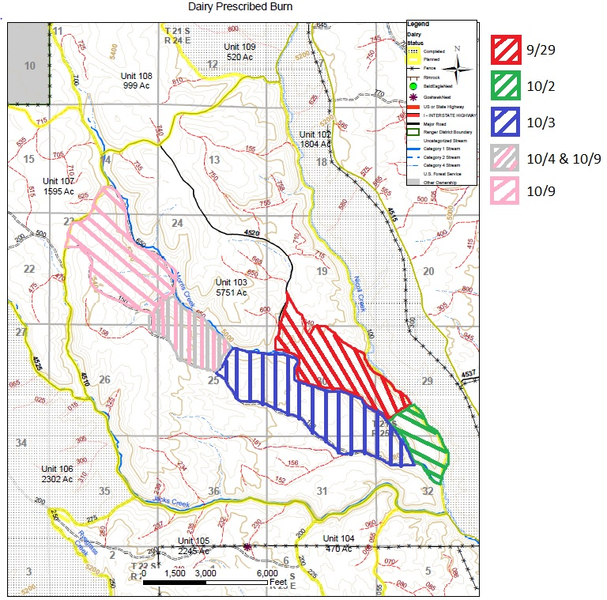
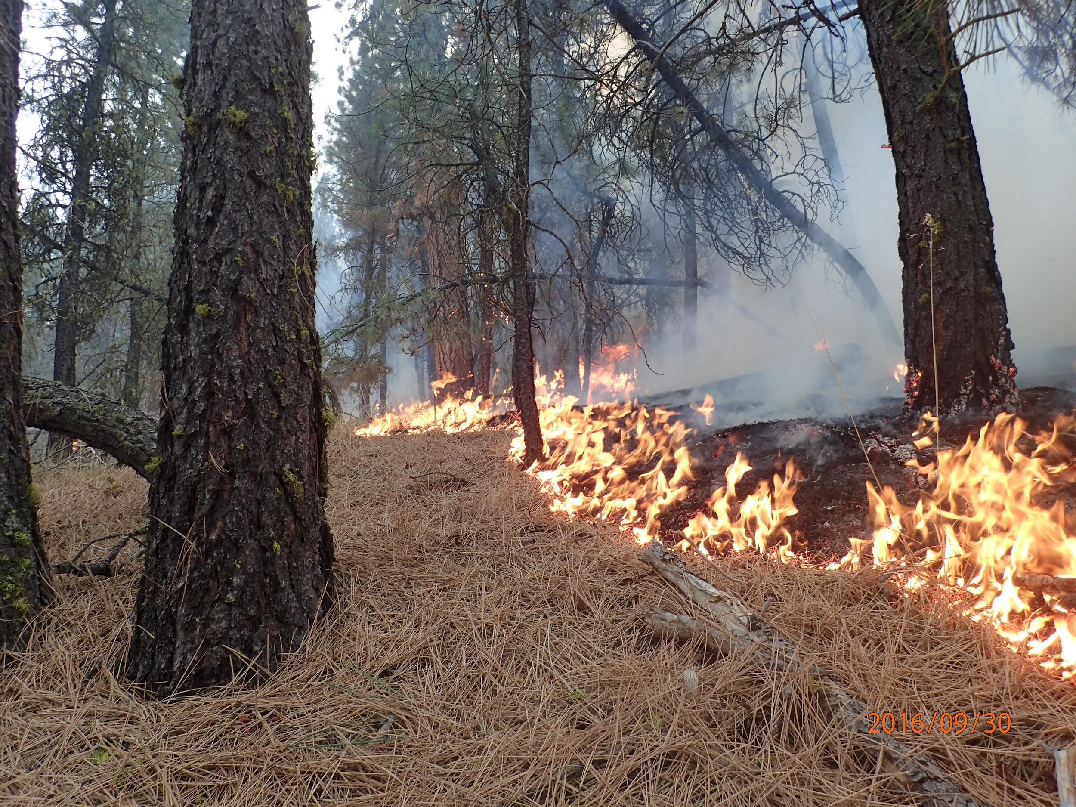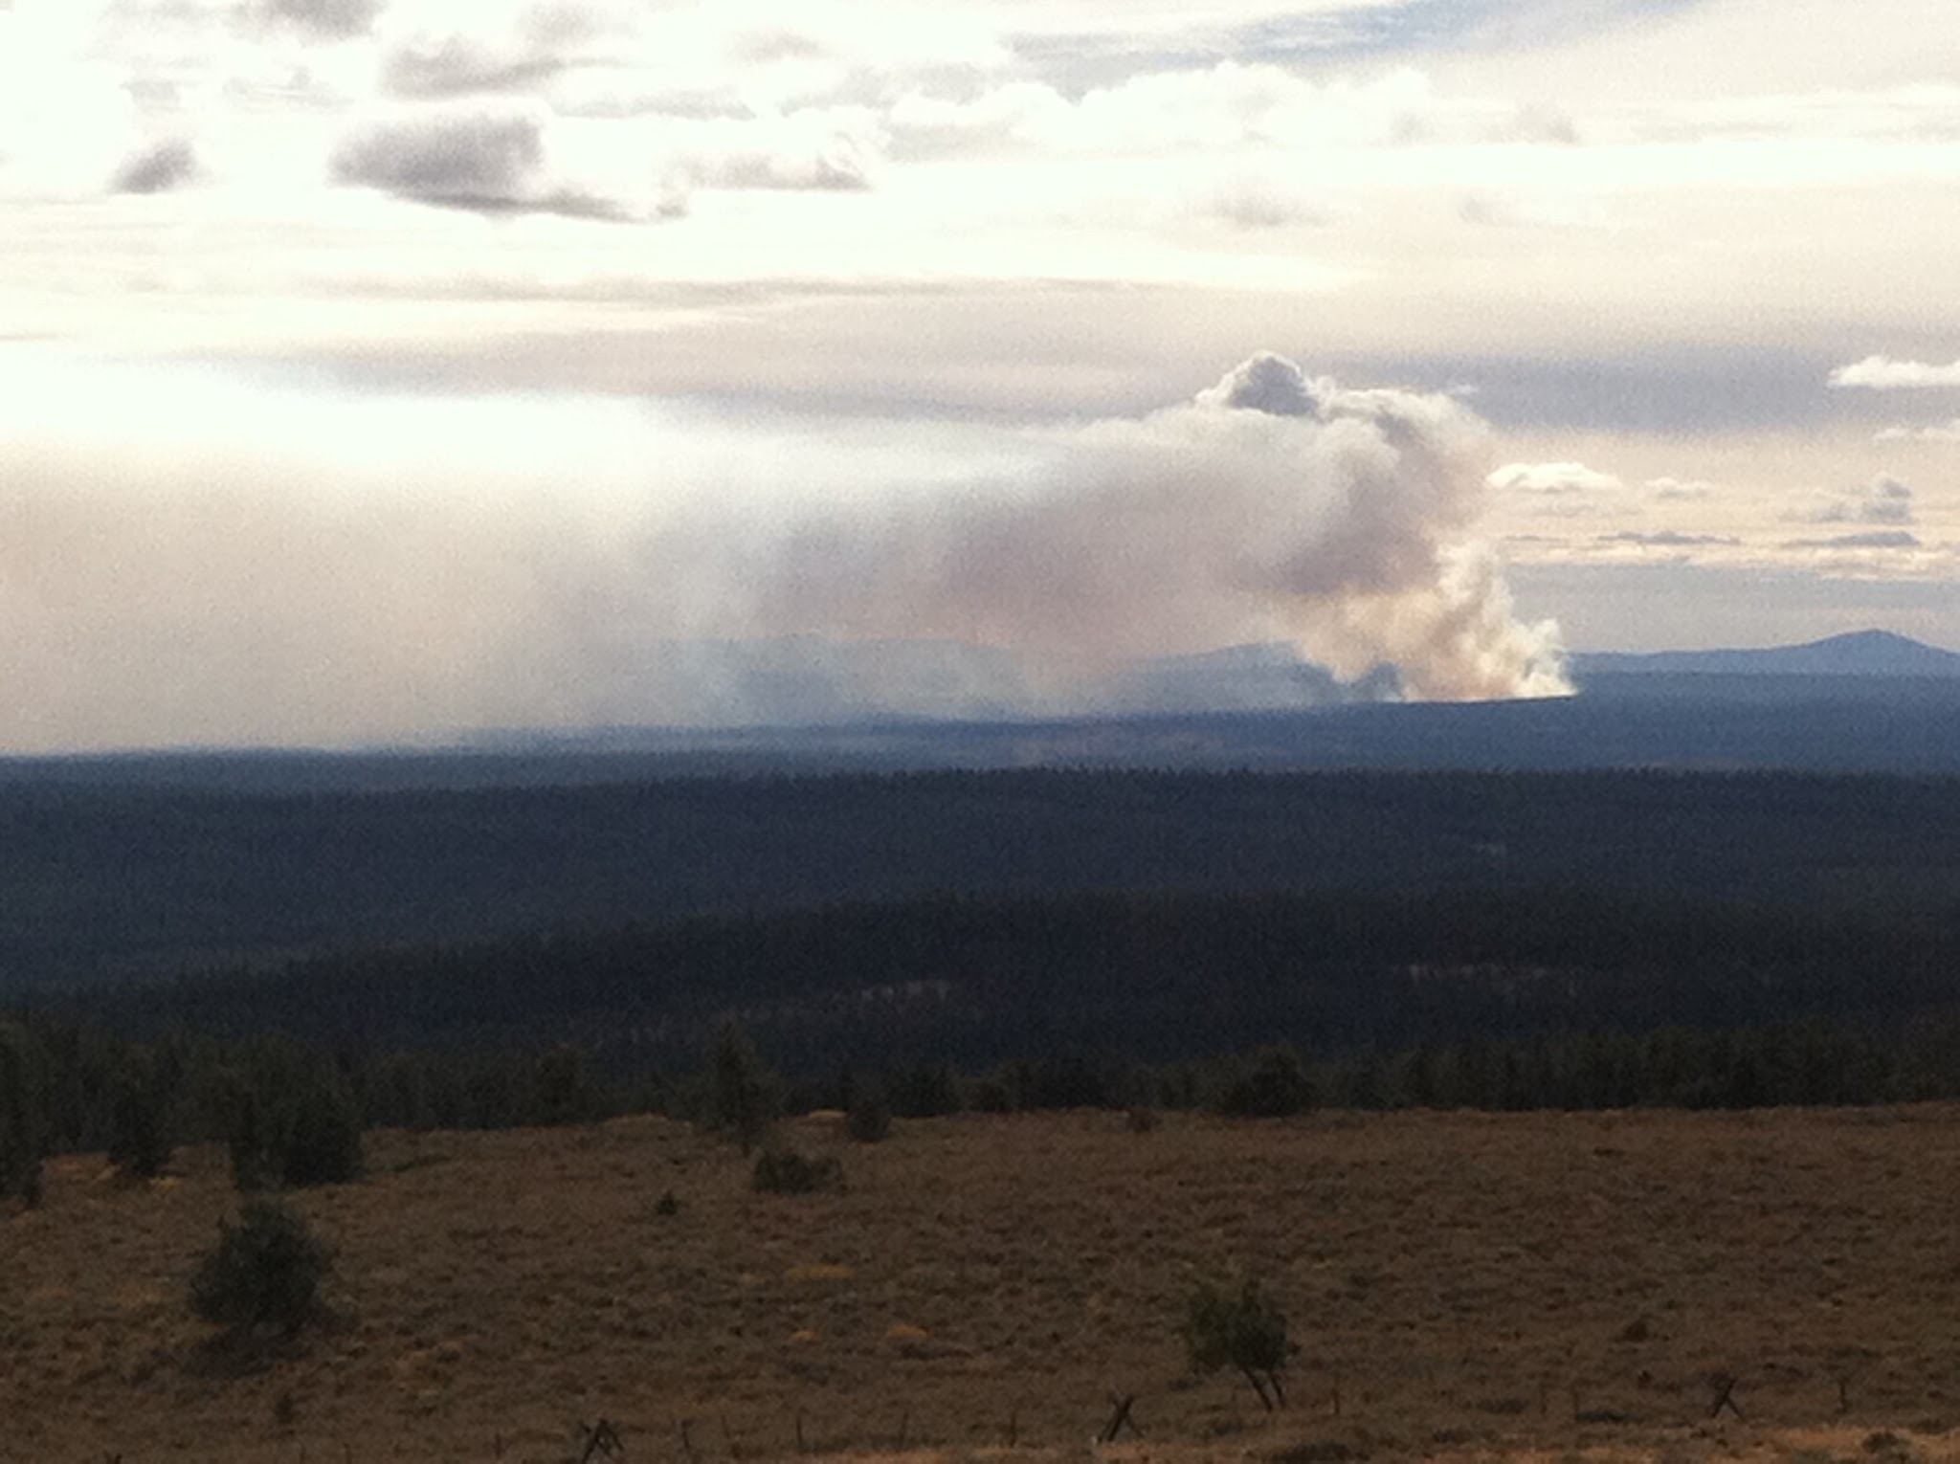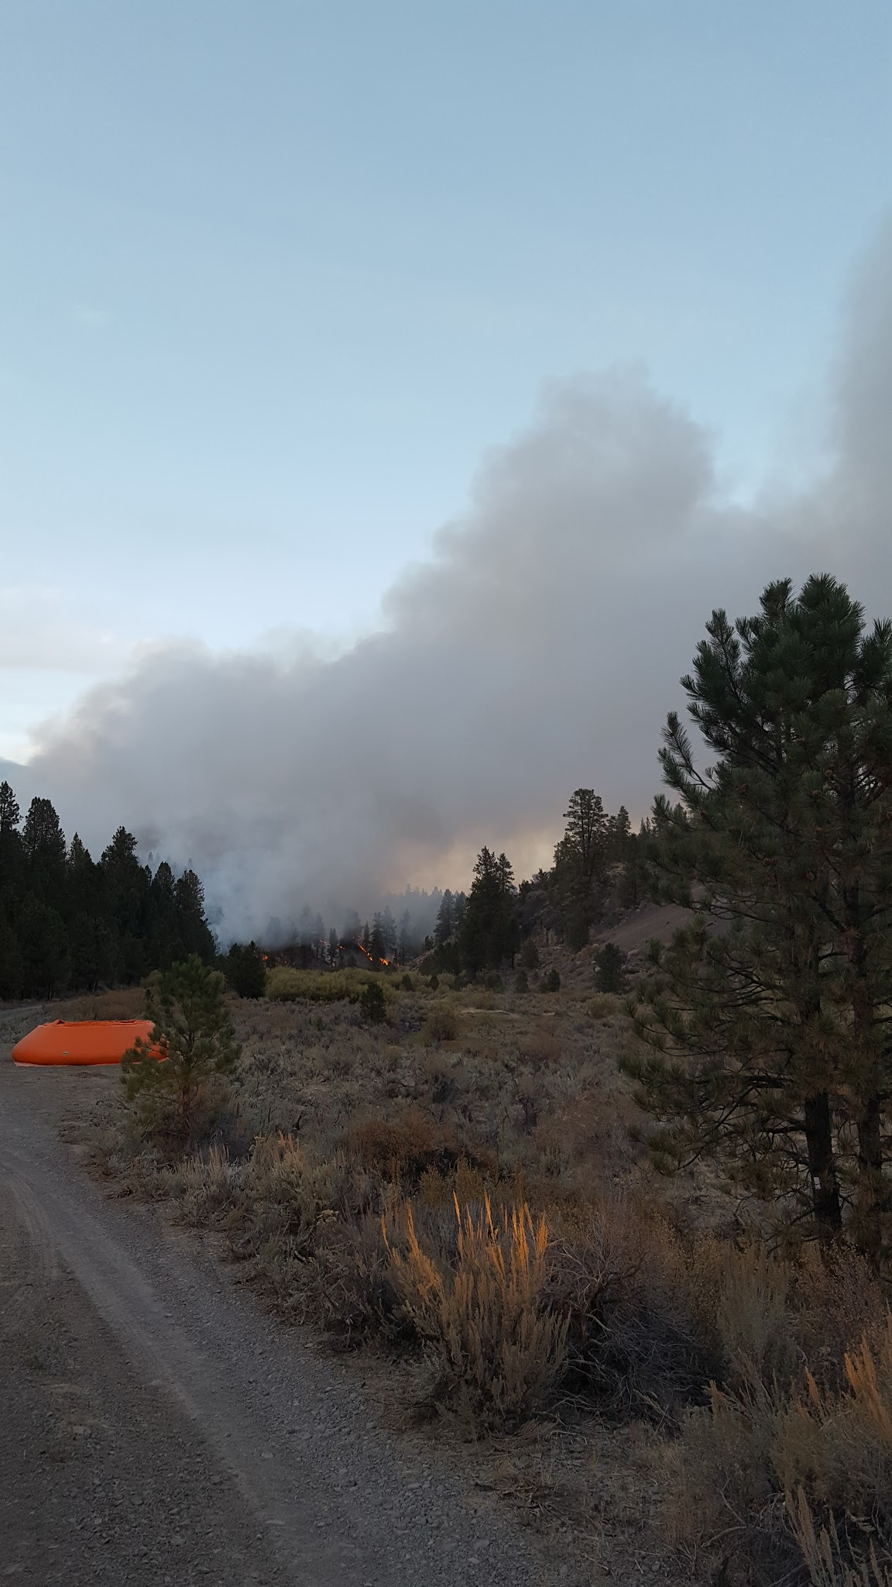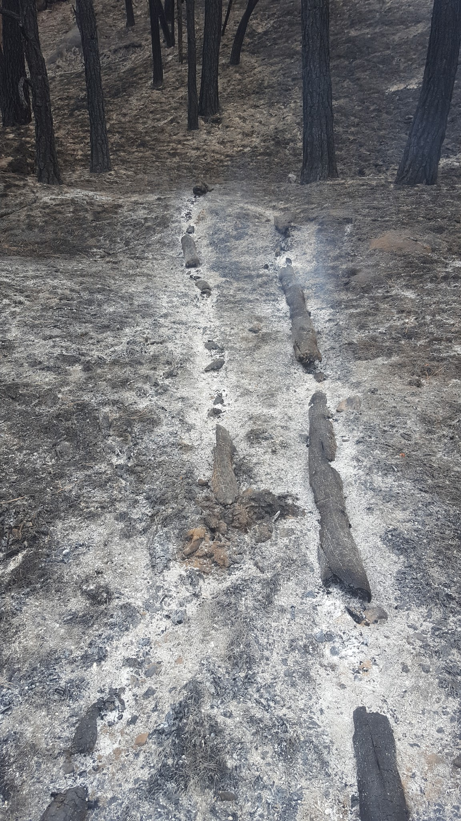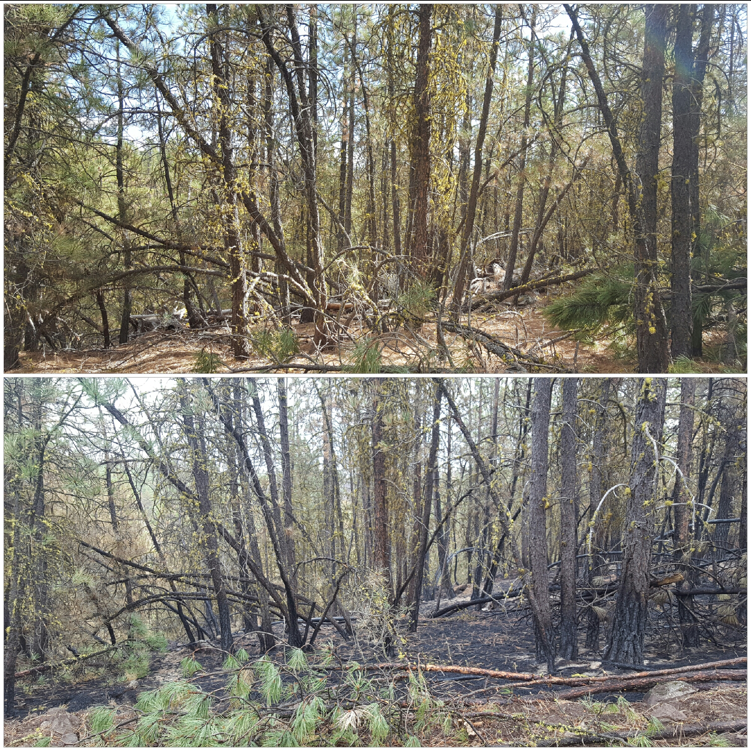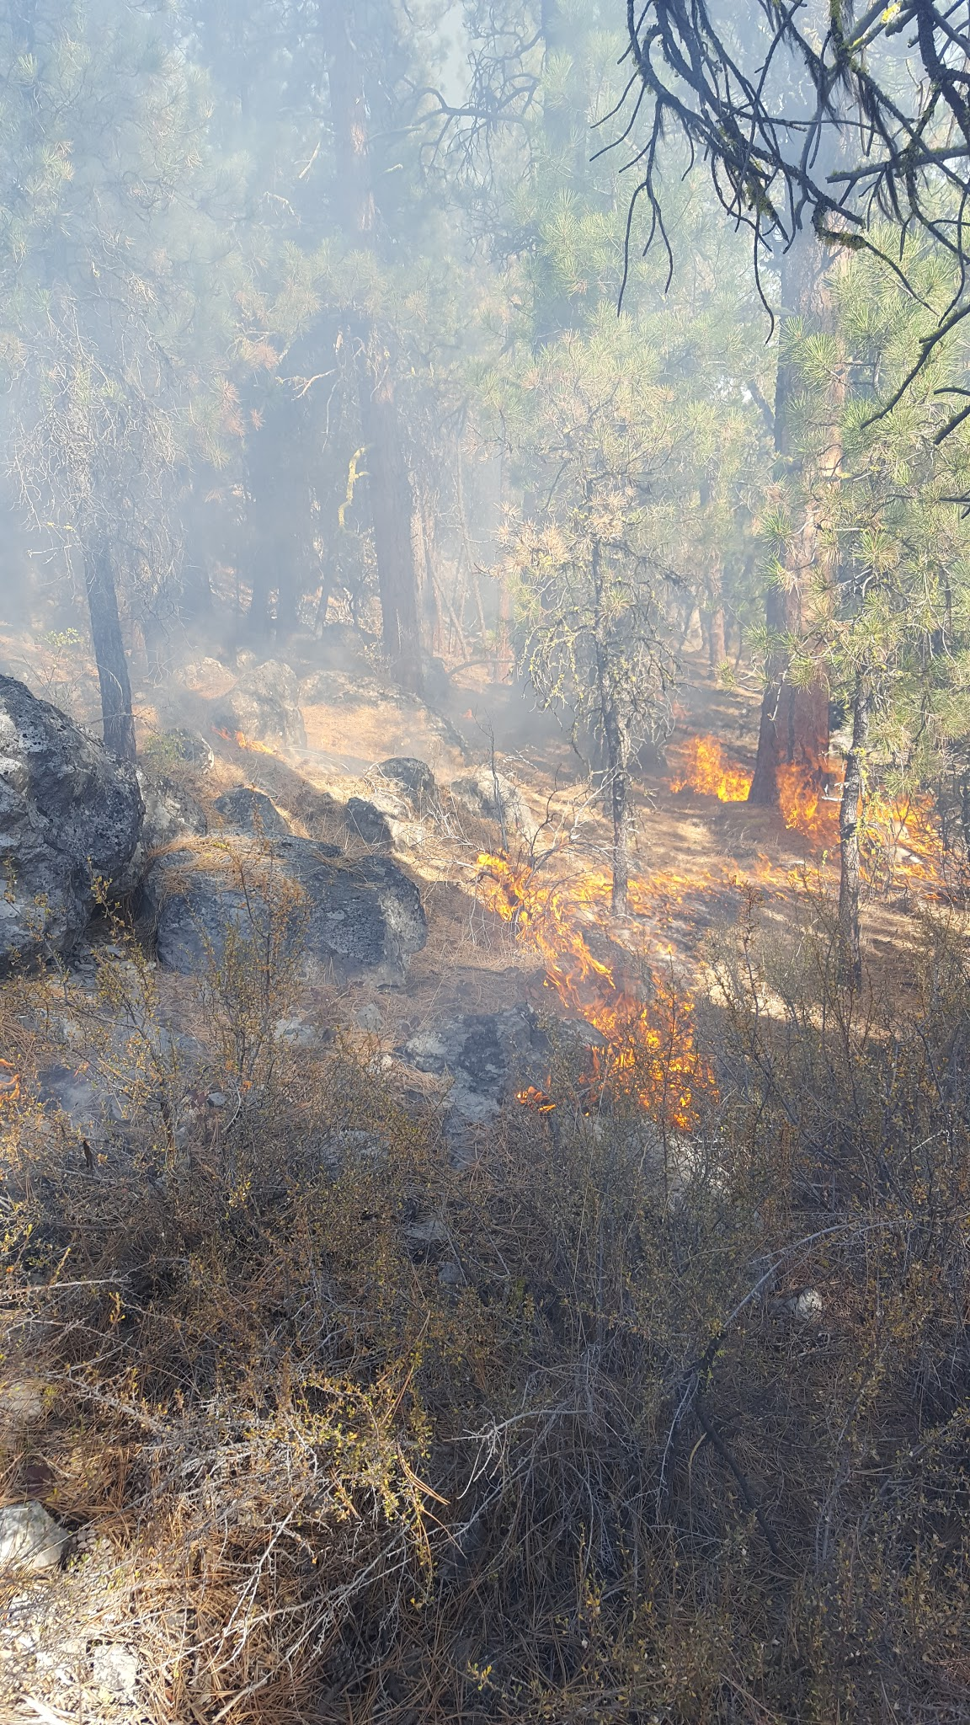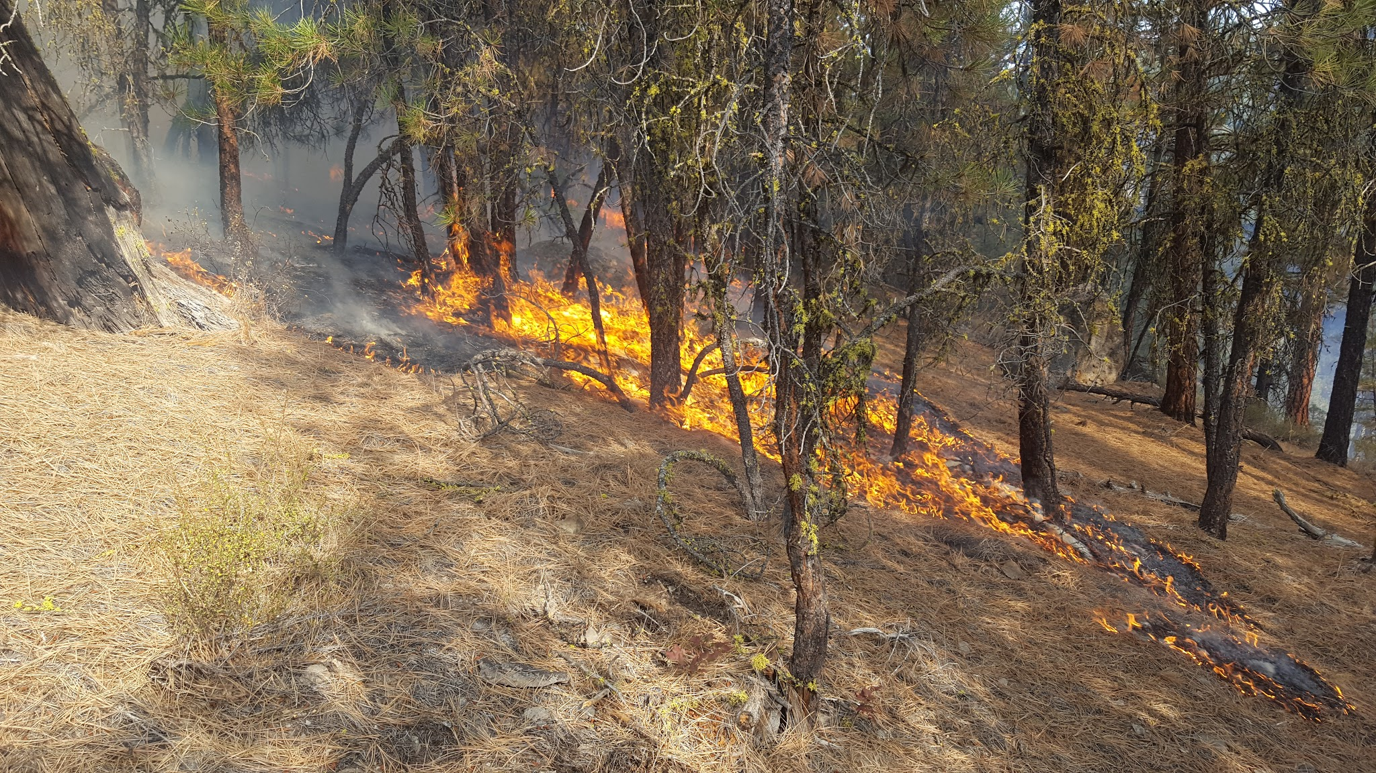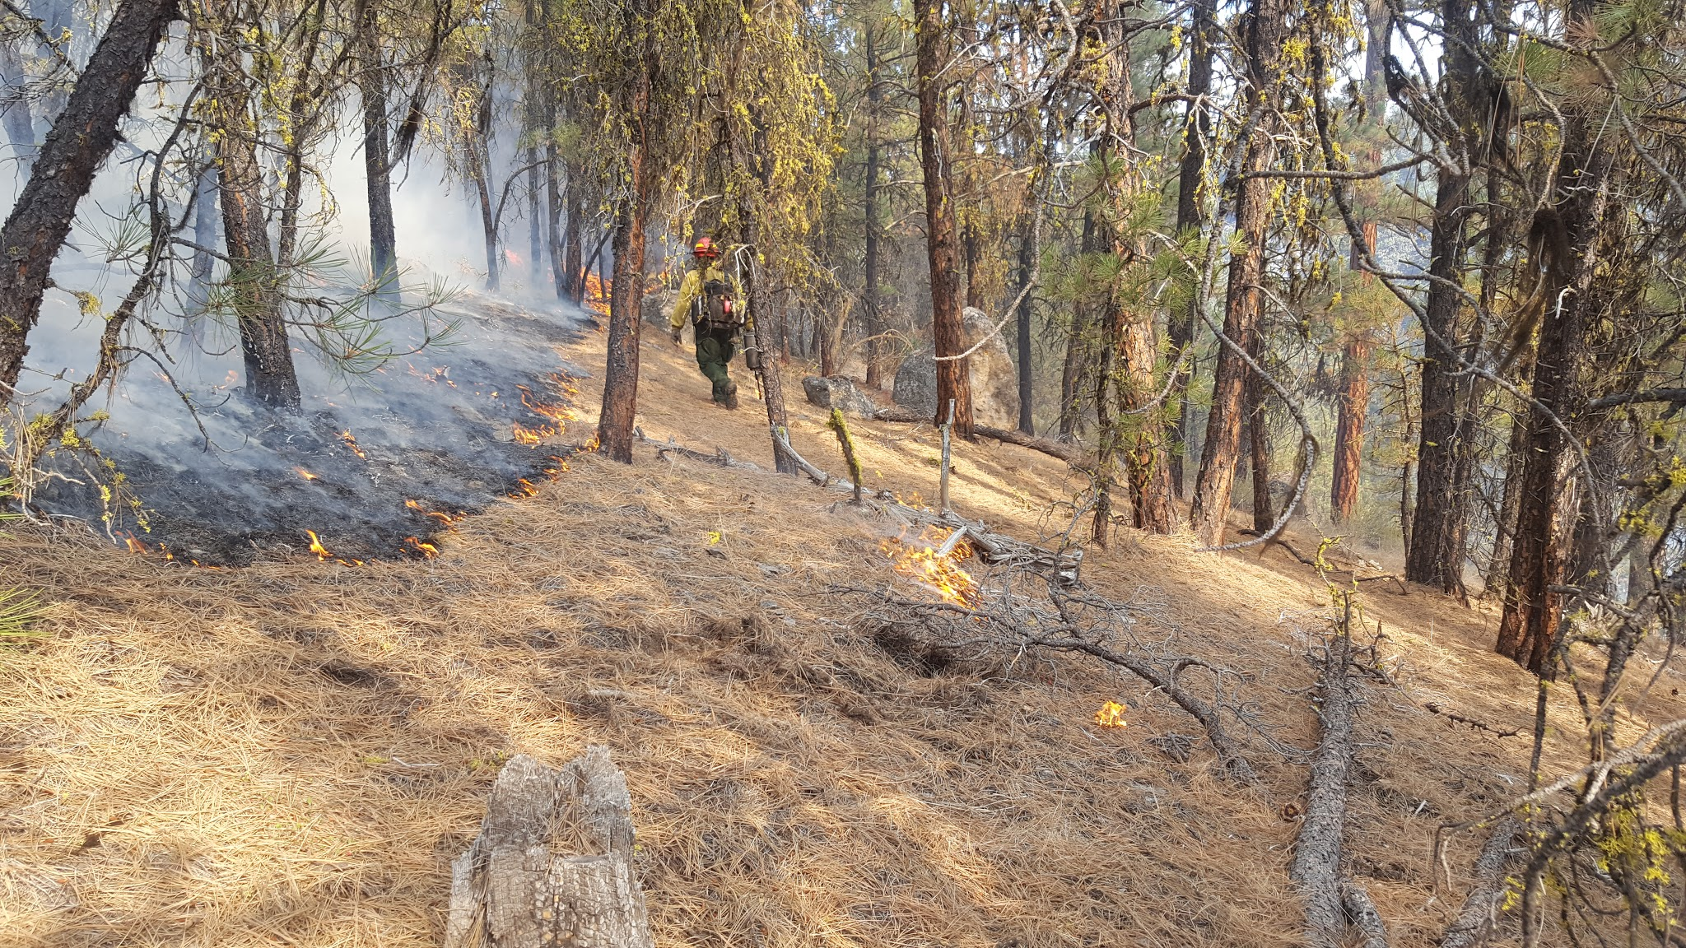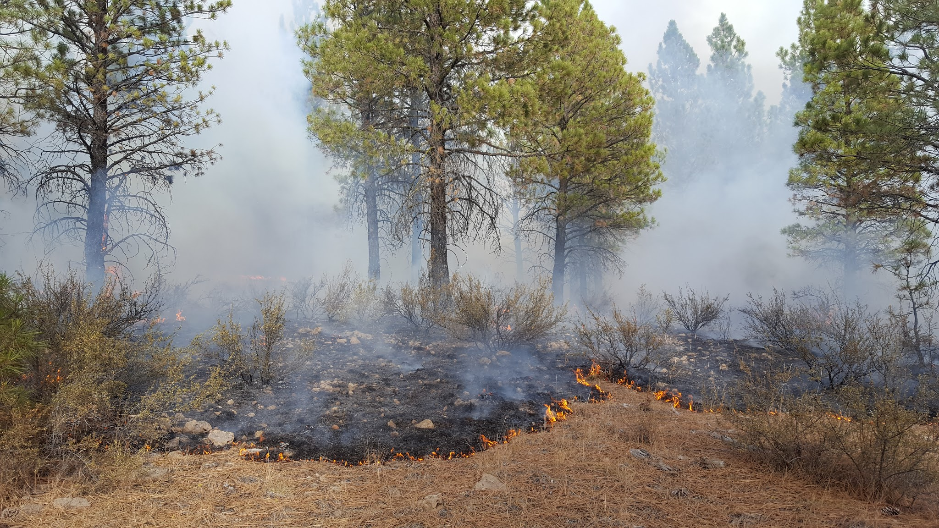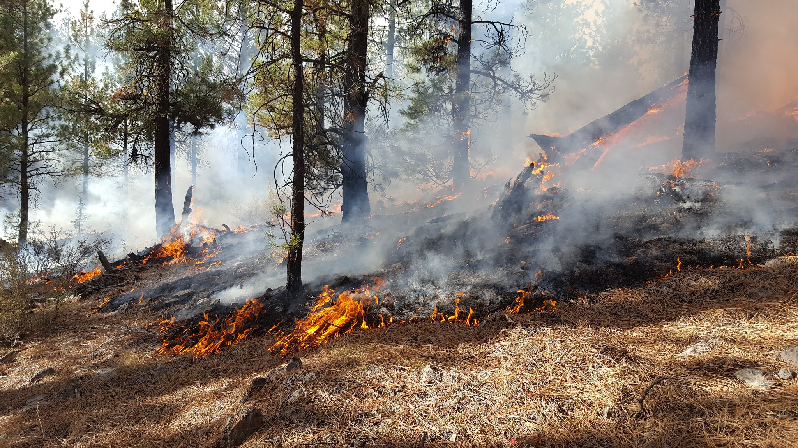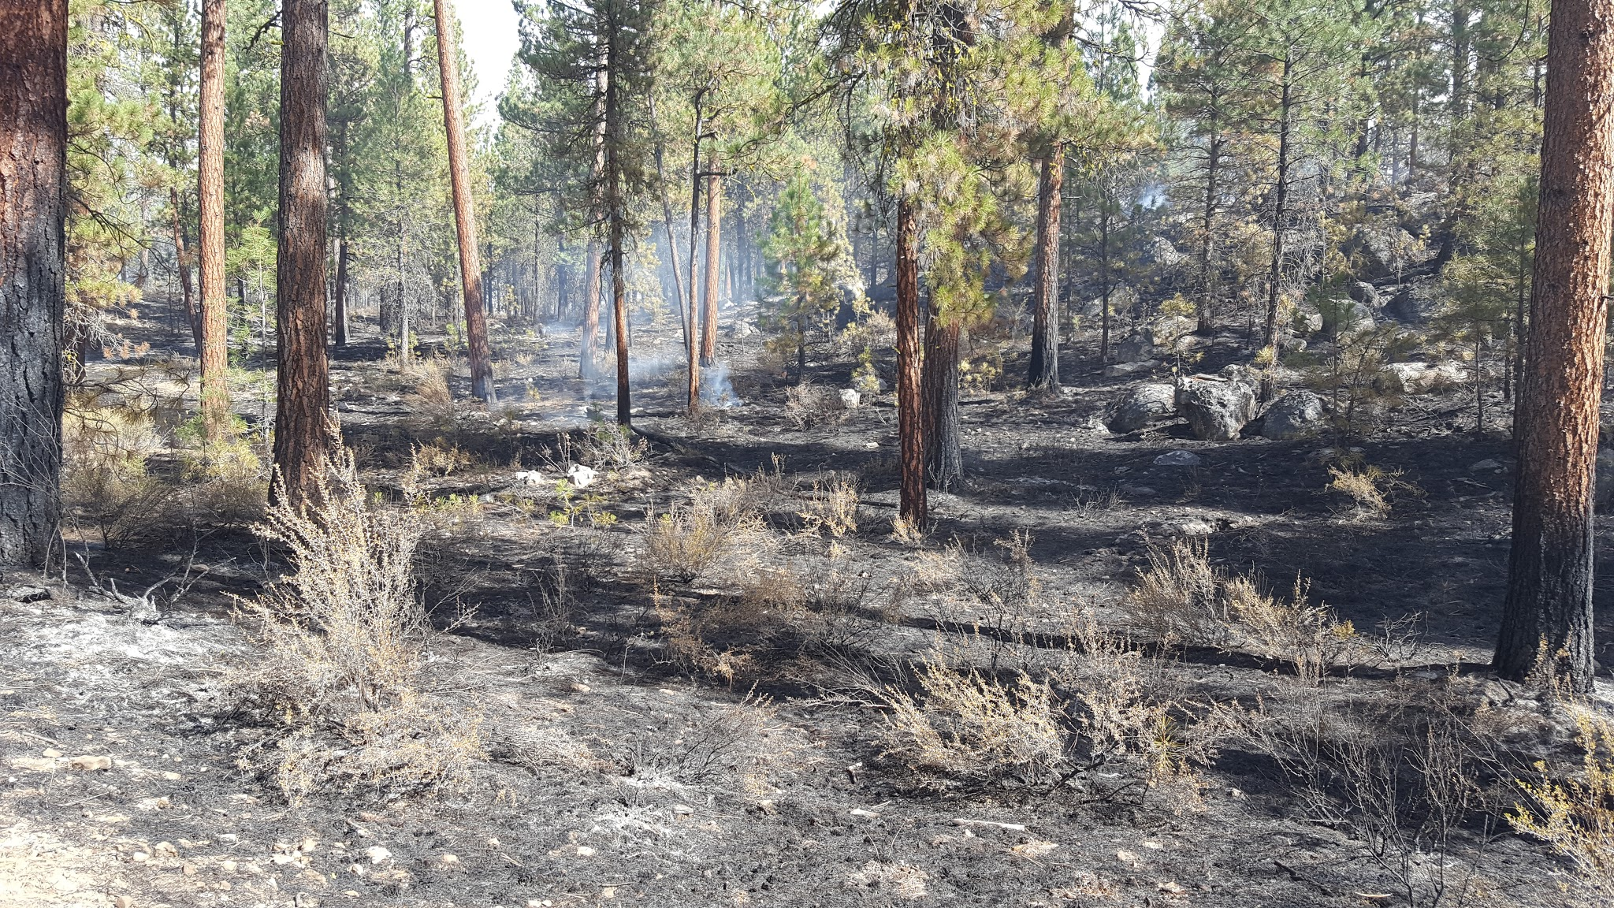

Weather Observations: 09/29/2016
Time | Wind Direction | Wind Speed (mph) | Dry Bulb (°F) | Wet Bulb (°F) | RH (%) | Cloud Cover (%) | POI (%) | Fine Dead (%)
0900 | Variable | 0-2 | 48 | 43 | 69 | 0 | 20 | 13
1000 | Variable | 0-2 | 68 | 54 | 42 | 0 | 30 | 10
1100 | E | 0-2 | 75 | 56 | 31 | 0 | 50 | 7
1200 | E | 0-2, gusts 7 | 77 | 56 | 27 | 10 | 60 | 5
1300 | E | 2-4, gusts 9 | 80 | 57 | 25 | 10 | 70 | 5
1400 | SE | 3-5, gusts 9 | 77 | 56 | 27 | 10 | 60 | 5
1500 | S | 3-5, gusts 7 | 77 | 55 | 25 | 20 | 60 | 5
1600 | S | 3-5, gusts 8 | 81 | 57 | 23 | 30 | 70 | 5
1700 | SE | 0-2 | 77 | 55 | 25 | 30 | 60 | 5
1800 | SE | 0-2 | 74 | 53 | 25 | 30 | 40 | 8
1900 | SE | 0-2 | 66 | 49 | 30 | 20 | 30 | 9
Weather Observations: 09/30/2016
Time | Wind Direction | Wind Speed (mph) | Dry Bulb (°F) | Wet Bulb (°F) | RH (%) | Cloud Cover (%) | POI (%) | Fine Dead (%)
0730 | Variable | 0-2 | 50 | 44 | 64 | 0 | 20 | 12
0800 | Variable | 0-2 | 50 | 45 | 70 | 0 | 30 | 10
0830 | Variable | 0-2 | 51 | 45 | 65 | 0 | 40 | 7
0900 | Variable | 0-2 | 44 | 40 | 73 | 10 | 10 | 14
1000 | E | 0-2, gusts 5 | 59 | 47 | 42 | 30 | 30 | 10
1100 | S | 2-4, gusts 6 | 63 | 48 | 34 | 80 | 50 | 7
1200 | SW | 0-2, gusts 5 | 67 | 49 | 27 | 80 | 50 | 6
1300 | NW | 0-2, gusts 7 | 69 | 52 | 33 | 100 | 50 | 6
1400 | NW | 2-4, gusts 8 | 70 | 52 | 30 | 100 | 60 | 6
1500 | NE | 2-4, gusts 9 | 69 | 51 | 29 | 100 | 50 | 6
1600 | NE | 2-4, gusts 7 | 66 | 49 | 30 | 100 | 50 | 7
1700 | NE | 0-2, gusts 4 | 67 | 51 | 34 | 100 | 50 | 7
1800 | NE | 0-3 | 64 | 48 | 31 | 100 | 30 | 9
1900 | NE | 0-2 | 64 | 49 | 35 | 100 | 30 | 10

Weather Observations: 10/01/2016
Time | Wind Direction | Wind Speed (mph) | Dry Bulb (°F) | Wet Bulb (°F) | RH (%) | Cloud Cover (%) | POI (%) | Fine Dead (%)
0900 | Variable | 0-2 | 38 | 32 | 55 | 0 | 20 | 12
1000 | NE | 2-4, gusts 6 | 46 | 38 | 50 | 0 | 20 | 11
1100 | NE | 0-2 | 49 | 39 | 42 | 80 | 30 | 9
1200 | NW | 0-2, gusts 5 | 51 | 40 | 39 | 80 | 40 | 7
1300 | NE | 3-5, gusts 10 | 55 | 43 | 38 | 60 | 40 | 7
1400 | SW | 3-5, gusts 10 | 53 | 41 | 36 | 60 | 40 | 7
1500 | SW | 2-4 | 56 | 43 | 35 | 40 | 50 | 6
1600 | SW | 2-4, gusts 6 | 57 | 43 | 32 | 40 | 40 | 7

Weather Observations: 10/02/2016
Time | Wind Direction | Wind Speed (mph) | Dry Bulb (°F) | Wet Bulb (°F) | RH (%) | Cloud Cover (%) | POI (%) | Fine Dead (%)
1000 | SE | 0-2 | 51 | 41 | 46 | 10 | 20 | 11
1100 | SE | 2-4, gusts 8 | 53 | 42 | 41 | 40 | 40 | 8
1200 | SE | 0-2 | 52 | 41 | 40 | 70 | 40 | 8
1300 | SE | 2-4, gusts 8 | 52 | 42 | 45 | 90 | 30 | 10
1400 | NE | 0-2, gusts 6 | 56 | 44 | 39 | 70 | 40 | 7
1500 | SE | 0-2, gusts 7 | 55 | 43 | 40 | 70 | 40 | 7
1600 | NE | 2-4, gusts 9 | 50 | 40 | 43 | 90 | 40 | 8
1700 | SE | 0-2, gusts 5 | 50 | 41 | 48 | 80 | 30 | 9
1800 | NE | 0-2 | 46 | 38 | 50 | 60 | 20 | 11

Weather Observations: 10/03/2016
Time | Wind Direction | Wind Speed (mph) | Dry Bulb (°F) | Wet Bulb (°F) | RH (%) | Cloud Cover (%) | POI (%) | Fine Dead (%)
1000 | SE | 0-2, gusts 5 | 45 | 37 | 49 | 10 | 20 | 11
1100 | NE | 0-2, gusts 5 | 44 | 38 | 60 | 10 | 30 | 10
1200 | NW | 0-3 | 49 | 40 | 47 | 20 | 40 | 8
1300 | NW | 2-4, gusts 6 | 51 | 41 | 44 | 30 | 40 | 7
1400 | NW | 0-2 | 52 | 41 | 40 | 30 | 40 | 7
1500 | NW | 0-2 | 52 | 40 | 35 | 50 | 40 | 7
1600 | NW | 0-3 | 52 | 41 | 40 | 70 | 40 | 8
1700 | W | 2-4, gusts 6 | 50 | 39 | 38 | 50 | 40 | 8
1800 | NW | 0-2 | 50 | 40 | 43 | 40 | 30 | 10

Weather Observations: 10/04/2016
Time | Wind Direction | Wind Speed (mph) | Dry Bulb (°F) | Wet Bulb (°F) | RH (%) | Cloud Cover (%) | POI (%) | Fine Dead (%)
1000 | NW | 0-2 | 44 | 41 | 80 | 80 | 10 | 15
1100 | NE | 2-4, gusts 6 | 48 | 43 | 69 | 90 | 20 | 11
1200 | SW | 2-4 | 47 | 42 | 68 | 30 | 30 | 10
1300 | NE | 2-4, gusts 7 | 51 | 44 | 60 | 70 | 30 | 9
1400 | W | 2-4, gusts 6 | 46 | 40 | 62 | 100 | 30 | 10
1500 | W | 2-4, gusts 6 | 49 | 42 | 58 | 80 | 30 | 9

Weather Observations: 10/05/2016
Time | Wind Direction | Wind Speed (mph) | Dry Bulb (°F) | Wet Bulb (°F) | RH (%) | Cloud Cover (%) | POI (%) | Fine Dead (%)
1000 | W | 0-2 | 45 | 39 | 61 | 100 | 30 | 9
1100 | NW | 0-2 | 39 | 38 | 92 | 100 | 10 | 15
1200 | NW | 0-2 | 39 | 37 | 85 | 100 | 10 | 13
1300 | NW | 0-2 | 42 | 41 | 93 | 100 | 10 | 14

Weather Observations: 10/09/2016
Time | Wind Direction | Wind Speed (mph) | Dry Bulb (°F) | Wet Bulb (°F) | RH (%) | Cloud Cover (%) | POI (%) | Fine Dead (%)
0900 | S | 2-4, gusts 7 | 54 | 48 | 67 | 10 | 20 | 13
1000 | S | 2-4, gusts 6 | 58 | 49 | 55 | 40 | 30 | 10
1100 | W | 0-3, gusts 5 | 62 | 51 | 49 | 20 | 30 | 9
1200 | NW | 0-3, gusts 5 | 63 | 50 | 42 | 20 | 50 | 7
1300 | NW | 0-2, gusts 6 | 65 | 50 | 36 | 10 | 50 | 7
1400 | W | 0-2, gusts 5 | 65 | 50 | 36 | 50 | 50 | 7
1500 | SW | 2-4 | 64 | 51 | 43 | 20 | 50 | 7
1600 | SW | 2-4, gusts 7 | 67 | 51 | 34 | 30 | 50 | 7
1700 | SW | 0-2, gusts 5 | 65 | 50 | 36 | 80 | 40 | 8
1800 | SW | 0-2, gusts 4 | 62 | 48 | 37 | 20 | 30 | 10

