Payette National Forest
Krassel Ranger District
Fire Effects Monitoring Report

Unit: Bald Hill RX Unit F and G Date: April 16 – 18, 2021

Fuel Type: Ponderosa Pine Litter
Fuel Model: TL 8
Acres Planned: 4000
Acres Burned: 1800

FEMO: Heather Heward, Christine Droske
FEMO (t): Steven Becker

Fire Effects and Meeting Objectives:
Fire behavior remained low throughout the burn period with rates of spread around 3 ch/hr and flame lengths 1-3 feet. Handn ignition was used along property lines, unit boundaries and RCAs. Aerial ignition by PSD was used for the rest of the unit starting at snow line and progressively working down slope. Resource and prescribed fire objectives were met by the burn.

Purpose and Resource Management Goals:
- Manage vegetation to meet desired future conditions as specified in the Forest Plan.
  - Promote growth of medium sized trees to large size class.
  - Reduce canopy closure in areas that have existing high canopy closures.
- Manage fire within its historic fire return interval.
- Prevent active ignition in RCAs (300’ perennial, 150’ intermittent), but allow fire to back into these areas

Resources
- Overhead 4
- Femos/ trainees 3
- Helicopter 1
- Type 4 Engines 2 (6 total personnel between the 2)
- BLM handcrew 4
- Krassel Helitack 4
- Boise handcrew 6
- Nez Perce handcrew 3
- UTV
- ATV
- Additional 4 helitack at helispot 2 HECM / 2 PLDO

Krassel Helitack 4 and one of the Type 4 engines were identified as contingency and were on site due to the long response time to the burn.

Specific Prescribed Fire Objectives:

Objective | Obtained
Fire in 40 – 80 % of target area | ~80% of target area burned | 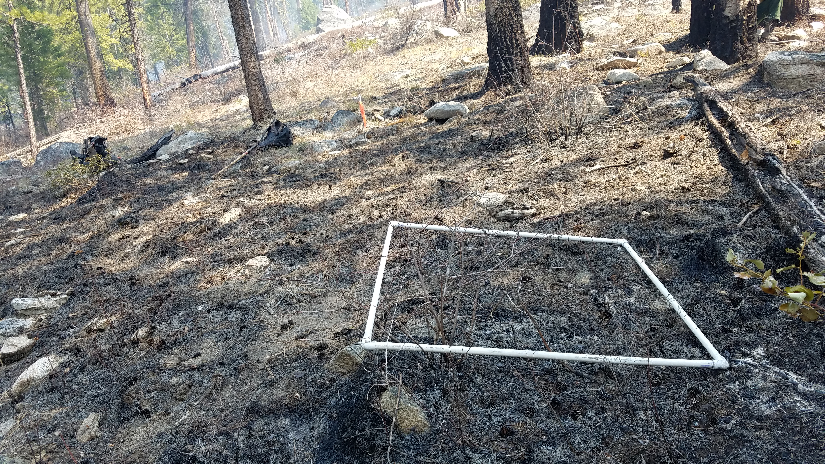
Mortality in trees >20 in. dbh <10% | Achieved | 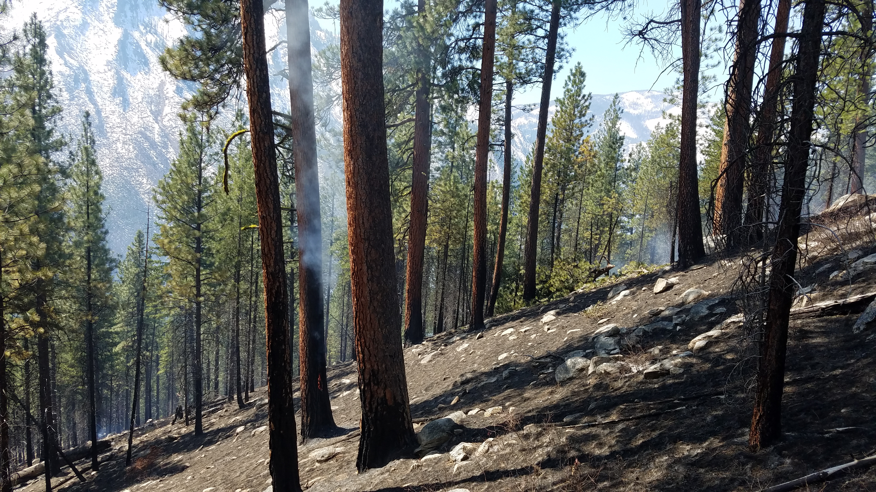
Retain 4 -10 tons/acre of material greater than 3” in diameter. | Achieved | 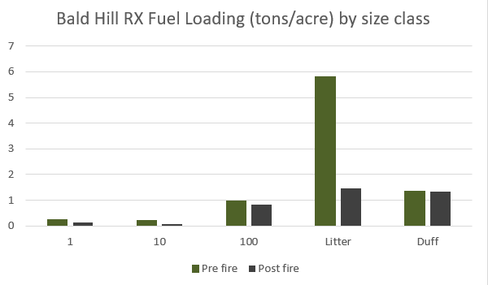
Minimize consumption of fuels over 15” in diameter | Achieved | 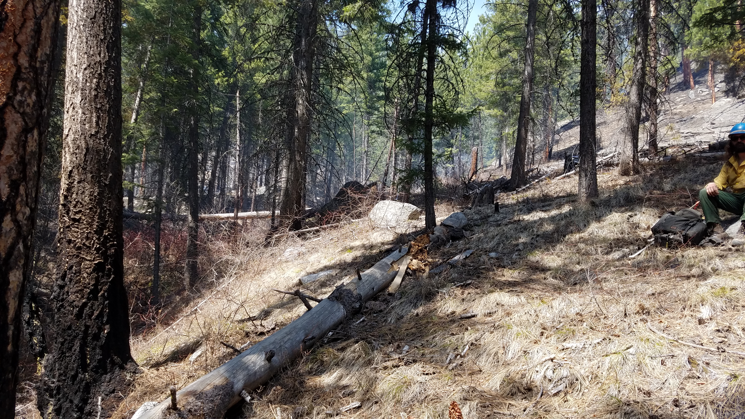
Maintain an average of 50% of the duff | Achieved (see table 1) | 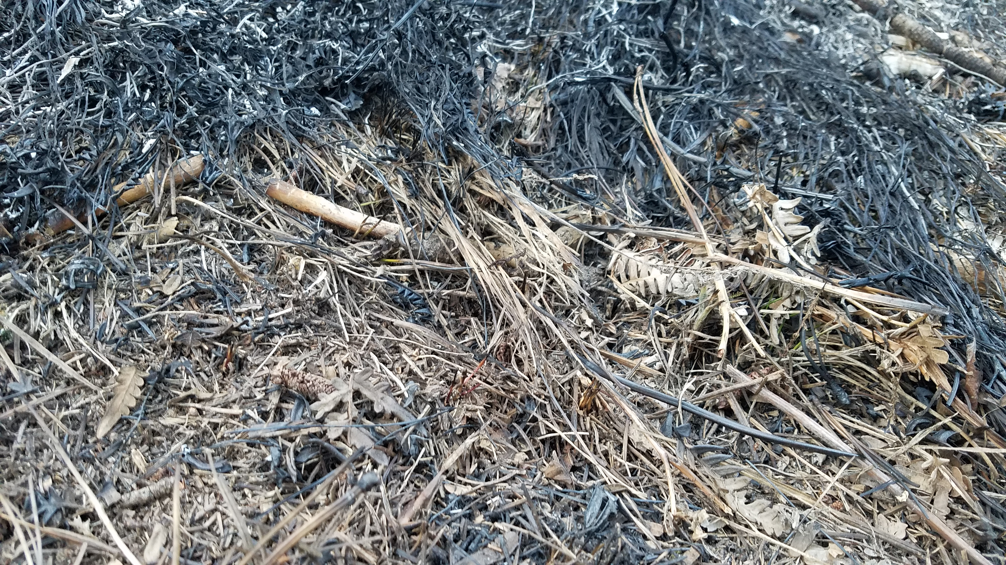
Limit fire in PVG 6 -11 (grand fir, subalpine fir, lodgepole pine) to less than 20% of its extent. | Achieved

Total loading reduction on the site

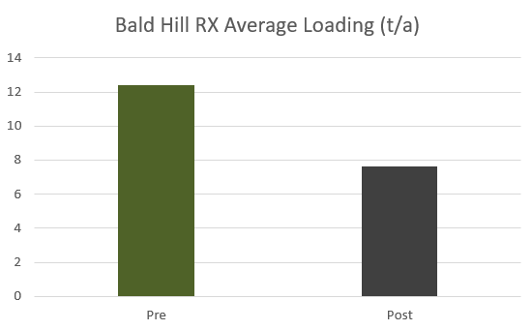

Site Description:
The burn unit is on a 20 to 70% slope with south aspect. This is a second RX entry in primarily uneven-age stand of ponderosa pines between 5-20” dbh with patches of Douglas-fir. The understory is mostly pine litter.

Observed fire behavior.
Fire behavior observatiosn were taken throughout the day on each burn. The general fire behavior was very similar each day

Pine litter
Head
FL – 1 to 3 ft
ROS – 2 to 4, maxing at 6 ch/h
Back
FL – 0.5 to 1 ft
ROS – 0.5 to 1 ch/h

Low shrub (Oregon grape, kinikinick)
Head
FL – 0.5 to 1 ft
ROS – <0.5 ch/h

April 16th, 2021 (South portion of unit F)
0830 Briefing at the Whiskey Creek Parking
1120 Test fire east of whiskey creek
1900 Complete ignition

April 17th, 2021 (Unit F)
0830 Briefing at Krassel
1108 Test fire through aerial ignition
1200 First pass with aerial ignition consuming. Fuels receptive, fire working through rocks smoldering and creeping. Smoke lofting up, wispy. Isolated torching.
1330 Backing fire .5 to 1 ch/hr., smoke starting to shade out the unit.
1420 Ignitions tied into DP 2
1450 Started hand ignitions from DP 4-5
1510 Paused ignitions between DP 5 and 6 due to holding concerns.
1545 Ignitions resumed
1555 Completed ignitions at DP7. Smoke is light and wispy traveling upslope and then being carried to the south with the transport winds. Fire continuing to back downhill toward road. Primarily carrying through the needle cast.
1620 Return to Krassel
April 18th, 2021 (Unit G)
0800 Briefing at Krassel
1040 Test fire completed successfully black line ignitions begin
1050 Smoke moving west to east, pushing up hill due to terrain driven winds
1130 Aerial ignitions working with hand ignitions to get desired fire effects
1250 Hand ignitions begin on the southwest corner of G. Aerial ignitions are coming together. Slight increase in fire behavior, achieving desired results.
1340 Aerial ignitions seemed to be achieving desired results. Clean up with hand ignition along lower edges.
1730 Return to Krassel

Fire Weather

04.16.2021
TIME | LOCATION | DRY BULB | RH | WIND SPEED | WIND DIR. | % CLOUD COVER | FINE DEAD FUEL | PROB. OF IGNITION
1000 | DP 6 | 44 | 39 | Calm |  | 40 | 8 | 40
1100 | DP 3 | 45 | 28 | 3-5 | S | 30 | 7 | 40
1200 | DP 3 | 49 | 27 | 4-6 | S SW | 20 | 6 | 50
1300 | East of DP 3 | 52 | 21 | 4-6 | S SE | 20 | 5 | 60
1400 | DP 1.5 | 55 | 18 | 1-3 | E | 0 | 4/7 | 70/40
1500 | East of DP 1.5 | 53 | 15 | 1-3 | E | 0 | 4/7 | 70/40
1600 | West of DP 2 | 55 | 15 | 1-3 | SE | 0 | 5/7 | 60/40
1700 | DP 2 | 59 | 18 | 1-3 | S | 0 | 5/7 | 60/40
1800 | DP 1.5 | 59 | 19 | 1-3 | SW | 0 | 7/9 | 40/30
1900 | Below DP 2 | 58 | 19 | Calm |  | 0 | 7/9 | 40/30
1920 | Below DP 2 | 54 |  |  |  | 0

04.17 .21
TIME | LOCATION | DRY BULB | RH | WIND SPEED | WIND DIR. | % CLOUD COVER | FINE DEAD FUEL | PROB. OF IGNITION
1100 | DP 3.5 | 51 | 30 | 1-3 | w | 0 | 7/9 | 40/30
1200 | DP 3.5 | 53 | 26 | 1-3 | sw | 0 | 6/7 | 50/30
1300 | DP 4 | 57 | 22 | 3-5 | sw | 0 | 5/8 | 60/40
1400 | DP 3.5 | 59 | 21 | 1-3 | w | 0 | 5/8 | 60/40
1500 | DP 4 | 61 | 21 | 1-3 | s | 0 | 5/8 | 60/40
1600 | DP 5 | 62 | 19 | 1-3 | sw | 0 | 5/8 | 60/40

4.18.2021

TIME | LOCATION | DRY BULB | RH | WIND SPEED | WIND SPEED (GUSTS) | WIND DIR. | FINE DEAD FUEL | PROB. OF IGNITION
1000 | DP 9 | 47 | 45 | 1-3 |  | e | 10 | 30
1100 | In unit G | 54 | 38 | 1-3 |  | e | 10 | 30
1200 | In unit G | 60 | 34 | 03 |  | sw | 6/10 | 50/30
1300 | In unit G | 61 | 25 | 2-5 |  | sw | 6/9 | 50/30
1400 | DP 3.5 | 69 | 16 | 3-5 |  | sw | 4/7 | 70/40
1500 | DP12 | 68 | 16 | 3-5 | 7-10 | sw | 4/7 | 70/40
1600 | DP12 | 68 | 16 | 3-5 |  |  | 4/7 | 70/40
1700 | DP12 | 68 | 16 | 3-5 |  |  | 4/7 | 70/40

