NorCal TREX – Tule Creek Ranch
Oct 20, 2016
Erin Banwell, FEMO
Jessica Reeves, FEMOt
Laura Brodhead, FEMOt
Lacey England, FEMOt
Miller Bailey, FEMOt

Project Overview
The prescribed fire area is 17-18 acres within a larger 417 acre burn unit on the Tule Creek Ranch. This burn unit is a wedge-shaped portion of Unit 4A. The unit is surrounded by previously-burned areas and dozer roads – these were used as control lines for this burn.
Topography: Slopes range from 5-45%, however the majority of the unit ranges from 5-15%. Elevations range from 2300-2500’.
On-site fuels: The primary fuel models are GR2 and TL2. Most of the grass fuel type was composed of non-native annuals, in addition to yellow star thistle. Most of the forest area consists of oak woodlands with a conifer component, in a variety of different conditions. These conditions include: open oak woodland and conifer-encroached woodland.
Unique features: There is a shaded drainage running east-west through the middle of the unit.
Project Objectives
Burn Plan
- Safely maintain prescribed fire within control lines.
- Protect existing infrastructures.
- Reduce timber litter, shrub litter, oak woodland litter, and grass litter by 40-90%.
- Limit mortality of conifers > 6” dbh to 15% or less.
- Reduce conifers < 6” dbh by up to 80%, however try to maintain all sugar pine.
Resource Objectives
The primary objective is to return fire back to this fire-adapted landscape. Numerous resources objective will be met through reintroduction of fire in this area. These objectives include, but are not limited to:
- Reducing the risk of catastrophic wildfire
- Reduce conifer encroachment into oak woodlands

TIME | LOCATION | ELEV. | ASPECT | WIND DIR. | WIND SPEED | GUSTS | DRY BULB | WET BULB | RH | DEW POINT | % SLOPE | %CLOUD COVER | %CANOPY COVER | EXPOSED/ SHADED | FDFM Exp | FDFM Sh | PIG Exp | PIG Sh
1030 | Photo point 4A-1 | 2400 | E | SW | 2-3 | n/a | 44 | 43 | 93 | 42 | 0-30% | 50 | 0 | exp | 15 |  | 10 | 10
1200 | Photo point A-1 | 2400 | E | n/a | calm | n/a | 55 | 48 | 61 | 42 | 0-30% | 15 | 0 | exp | 9 |  | 30 | 30
1300 | Photo point A4-2 | 2500 | E | n/a | calm | n/a | 60 | 53 | 64 | 48 | 0-30% | 20 | 0 | exp | 9 |  | 30 | 30
1400 | Pond in DIVS B | 2450 | E | E | 2-3 | n/a | 66 | 57 | 59 | 51 | 0-30% | 15 | 0 | exp | 9 |  | 30 | 30
1500 | DIVS B, southern road | 2400 | E | NW | 2 | 5 | 70 | 59 | 53 | 52 | 0-30% | 10 | 0 | exp | 8 |  | 40 | 30
1600 | Near NW corner DIVS A | 2500 | E | NW | 3 | 5 | 72 | 60 | 51 | 51 | 0-30% | 10 | 0 | exp | 10 |  | 30 | 30
1700 | Bottom of DIVS B | 2400 | E | n/a | calm | n/a | 68 | 58 | 56 | 52 | 0-30% | 10 | 0 | exp | 10 | 13 | 30 | 20
Fire Weather Summary: Temperature ranged from 44 to 72 F, while RH ranged from 51 to 93%. Maximum probability of ignition was 40%. Wind direction was variable, ranging from 0 to 3 mi/hr, with gusts to 5 mi/hr around 1500.

Table 1. Weather observations for Tule Creek Ranch burn, Oct 20, 2016.

Fire Behavior Summary
The DIVS A test fire was done 1215 on an east aspect, on flat ground, and in an exposed grass and shrub component. Fuels consisted of invasive annual grasses and shrubs species including green-leaf and white-leaf manzanitas and buckbrush. Flame lengths were very low (<0.5’) and fire spread was minimal. Relatively high fine dead fuel moistures and relative humidity resulted in minimal fire behavior. The test fire burned itself out within minutes.
A second test fire was conducted in the same location at 1305. However, microsite conditions consisted of more pine needle cast. Fine dead fuel moisture and relative humidity were similar, but the needle cast was receptive and carried fire into the shrubs. Ignition operations were initiated in DIVS A at 1315.
The needle cast carried fire into and between the shrubs, which produced 3-10’ flame lengths. Sustained flame lengths were 2-3’. Fuels in the shade were not receptive to ignition.
The DIVS B test fire was done at 1340 on an east aspect, on flat ground, and in exposed grasses and cattails. Flames lengths were 2-4’ and fire spread was moderate. Ignition was continued downslope. The grasses species were the primary fire carrier in this division. However, any shaded fuels acted as fuel breaks. The result was a mosaic of burned and unburned areas.
This fire behavior continued as DIVS A and DIVS B came together in the lower part of the unit. However, there were 2 patches within the unit that experience significantly different fire behavior:
- The drainage in the center of the unit did not burn at all. The fuels were too shaded and wet to carry fire.
- A patch of conifers on the south end of DIVS B had very minimal fire spread. Canopy cover was approximately 60% and the duff layer was extremely wet.

Smoke Summary
In general, smoke was quick to rise 200’+, however column development was minimal. Smoke was dissipating and settling generally to the south and southwest. By 1800, after burning operations were done, a diurnal wind change was observed and smoke was settling in the north. Smoke was consistently white and wispy. There were occasional, short-lived dark plumes resulting from the shrub component.

Fire Effects Summary
In DIVS A, the needle cast and shrub litter was mainly consumed. The shrub component was fire-effected, but only approximately 20% consumed. Areas that did burn showed a variability of temperature, leading to a mosaic burn pattern. Post-fire data collection showed that pine seedling mortality was approximately 40%, with the remaining 60% fire-effected with questionable survivability in the next year. Overall mortality of conifers > 6” dbh was minimal; this meets the burn plan objective.
In DIVS B, approximately 75% of the grass component was consumed. There was large reduction of star thistle biomass on site. The variability in shading resulted in a mosaic burn pattern, as shaded fuels were not receptive.

Recommendations for Future on Prairie Unit:
This year, we burned on the cool/damp end of the burn prescription, which created challenges for meeting objectives. If the main objective was simply to reintroduce fire to this landscape as a first entry, that objective was met. In terms of ecological objectives and burn plan objectives, those were largely constrained by current weather conditions and left unmet. Aiming for days closer to the middle of the burn prescription would better accomplish these objectives.
Yellow star thistle biomass was largely reduced on this unit. This means that future re-entries during early summer burning windows to limit star thistle reproduction will be more feasible.

Problem Species:
- Yellow starthistle:
- Can reduce forage and habitat for wildlife, displace native plants, and reduce native plant and animal diversity (Sheley and Larson 1994)
- It can alter water cycles as its water use is particularly high – can use as much as 50% of stored soil moisture (Gerlach)

- Can be treated with fire! However, timing is everything. To reduce yellow starthistle, fire is most successful when used in early summer, June or July. May could potentially also work if June or July are not possible.
- 80% seedbank depleted in one year, around 96% in three years, nearly all depleted after four years. Therefore, 2-4 years of repeated early summer burns would likely reduce the population by over 90%.
- A first entry burn can increase yellow starthistle populations by stimulating/depleting the soil seedbank, so treatment in the first year after burn is critical!
- If you use 2-4 years of consistent early summer prescribed fire, it is important to drop fire use back down to match fire regime of prairies here, which is likely closer to 10 year intervals (could see fire history records to determine this if it is not well known).
- Grazing can also work during the bolting stage (before flowering) to limit starthistle populations.

Burn in June or July for three years in a row, then return to proper fire regime.
Citation for further info: http://www.cal-ipc.org/ip/management/pdf/YSTMgmtweb.pdf

SPOT Weather Forecast:

SPOT FORECAST FOR TULE CREEK UNIT 4A...THE NATURE CONSERVANCY
NATIONAL WEATHER SERVICE EUREKA CA
800 AM PDT THU OCT 20 2016
FORECAST IS BASED ON IGNITION TIME OF 0800 PDT ON OCTOBER 20.
IF CONDITIONS BECOME UNREPRESENTATIVE...CONTACT THE NATIONAL WEATHER
SERVICE.
.DISCUSSION...
HIGH PRESSURE WILL REMAIN OVER THE REGION THROUGH FRIDAY RESULTING
IN DRY WEATHER CONDITIONS WITH NO RAIN. WINDS WILL REMAIN LIGHT
AND DIURNALLY DRIVEN AND DAYTIME TEMPERATURES WILL WARM SLIGHTLY.

.TODAY...
TEMPERATURES.....9AM 49F, 11AM 57F, 1PM 64F, 3PM 72F, 5PM 73F, 7PM 58F.
LAL.................1.
MIXING HEIGHT.......300 TO 500 FT AGL INCREASING TO 3500 FT AGL
IN THE AFTERNOON.
MIN HUMIDITY........37 TO 45 PERCENT.
SKY/WEATHER.........MOSTLY SUNNY.
CWR.................0 PERCENT.
WIND (20 FT)........VARIABLE 1 TO 3 MPH...BECOMING WEST 4 TO 7 MPH
IN THE AFTERNOON.
TRANSPORT WINDS.....WEST 8 MPH IN THE AFTERNOON.

.TONIGHT...
MIN TEMPERATURE.....AROUND 35 TO 43.
LAL.................1.
MIXING HEIGHT.......3000 FT AGL DECREASING TO 500‐1000 FT AGL LATE
IN THE EVENING.
MAX HUMIDITY........89 TO 98 PERCENT.
SKY/WEATHER.........MOSTLY CLEAR.
CWR.................0 PERCENT.
WIND (20 FT)........WEST WINDS 5 TO 7 MPH BECOMING LIGHT AND VARIABLE.
TRANSPORT WINDS.....WEST 10 MPH.

.FRIDAY...
MAX TEMPERATURE.....AROUND 68 TO 73.
LAL.................1.
MIXING HEIGHT.......500 TO 1000 FT AGL INCREASING TO 2900‐3500 FT AGL
IN THE AFTERNOON.
MIN HUMIDITY........37 TO 45 PERCENT.
SKY/WEATHER.........PARTLY CLOUDY.
CWR.................0 PERCENT.
WIND (20 FT)........LIGHT WINDS...BECOMING WEST 4 TO 7 MPH IN THE AFTERNOON.
TRANSPORT WINDS.....WEST 10 MPH IN THE AFTERNOON.

$$
FORECASTER...DJB
REQUESTED BY...AMANDA STAMPER
TYPE OF REQUEST...PRESCRIBED.TAG 1601871.0/EKA

Photo Points
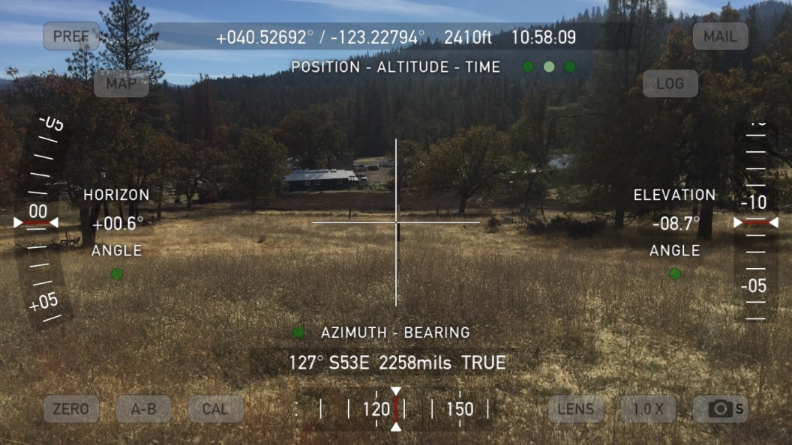
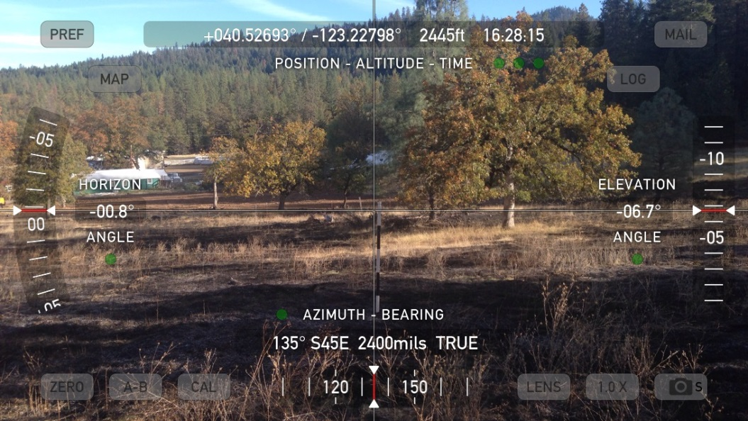
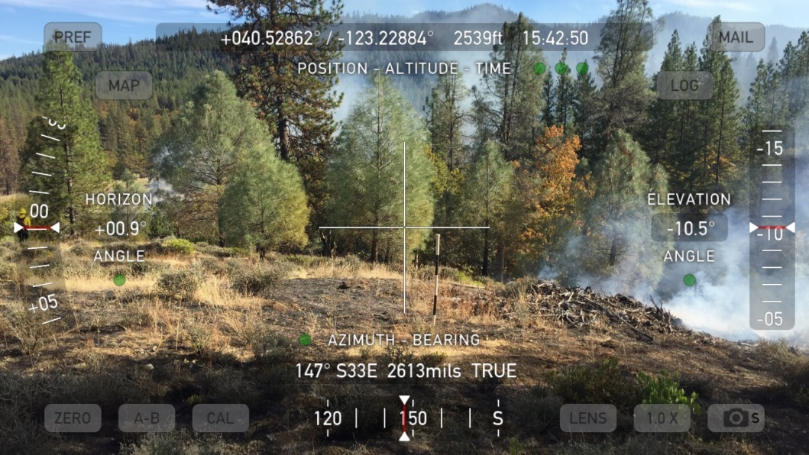
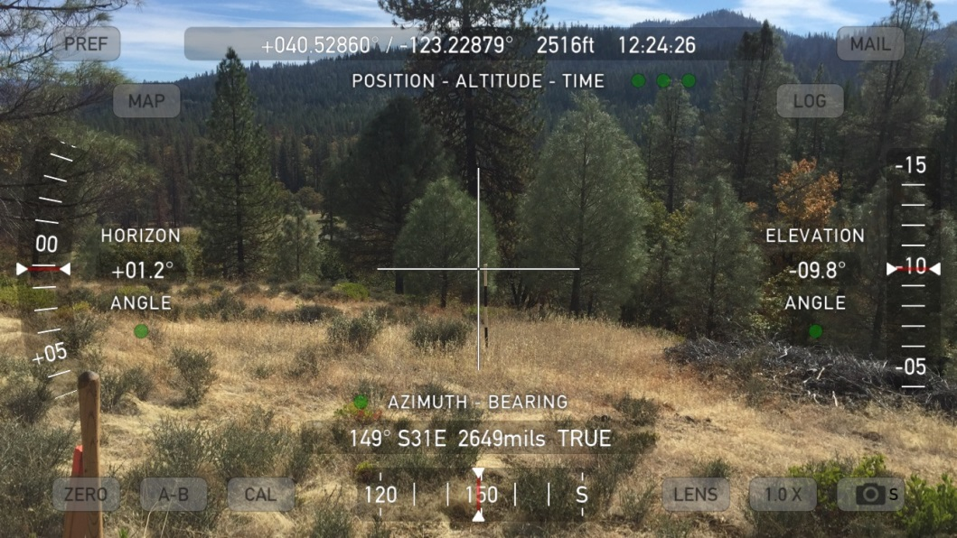
Pre-fire Post-fire

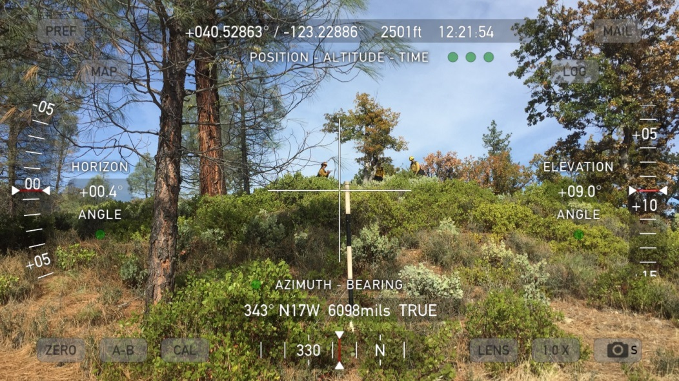
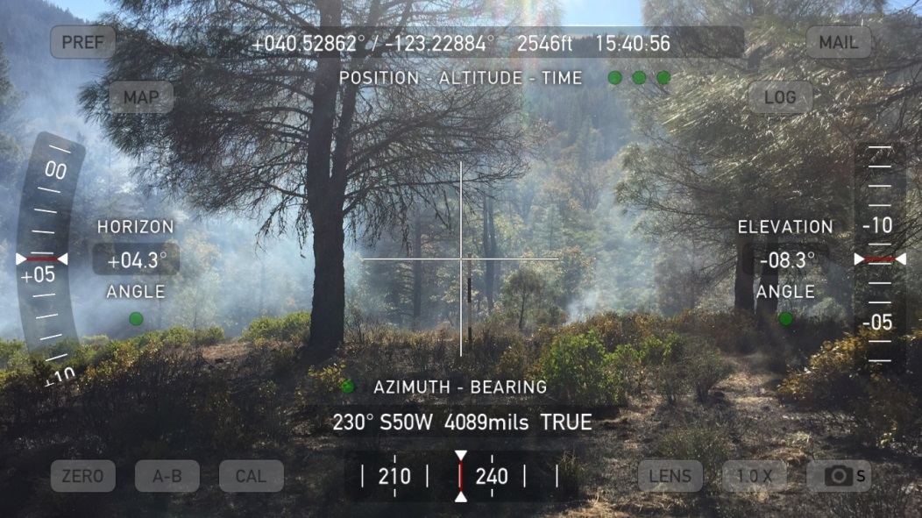
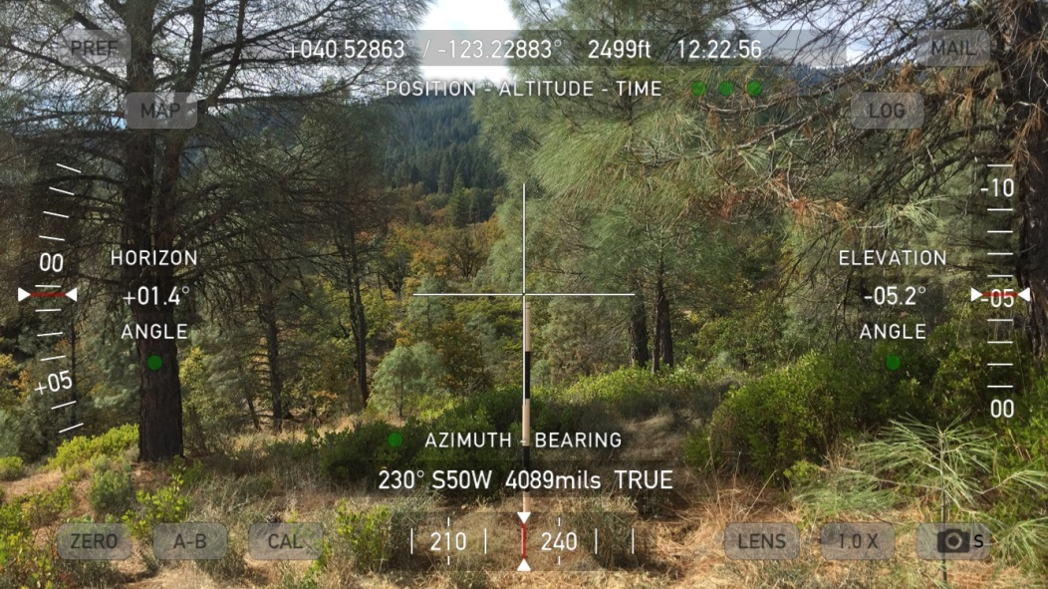
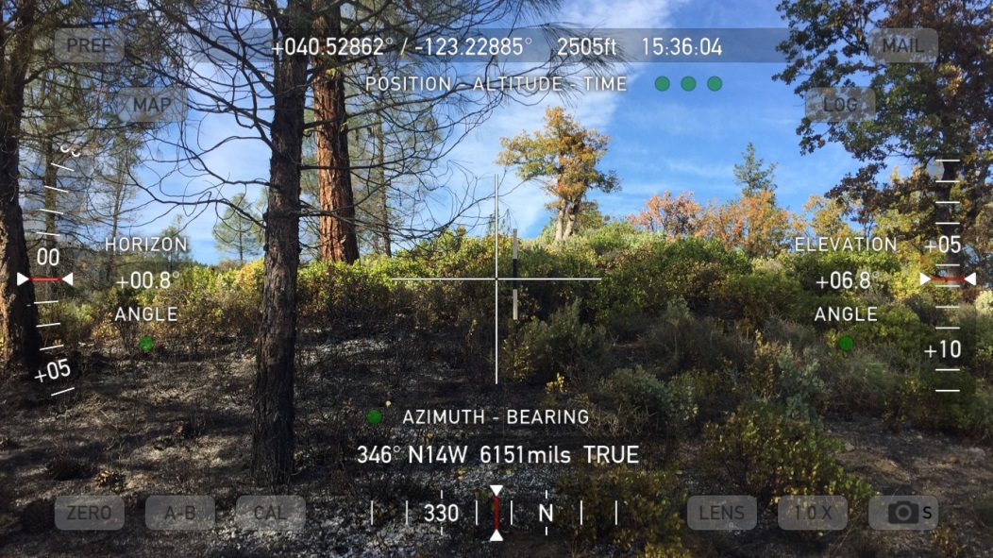
Pre-fire Post-fire
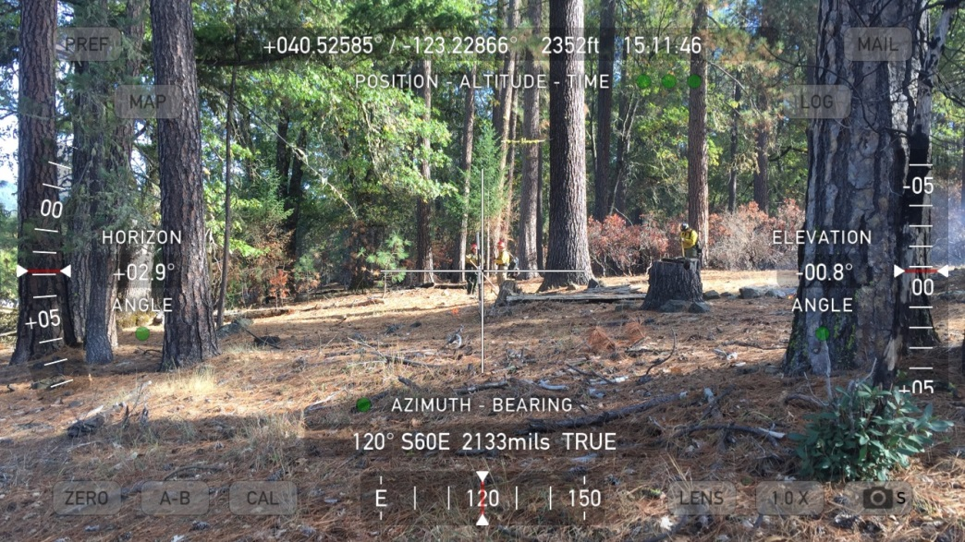
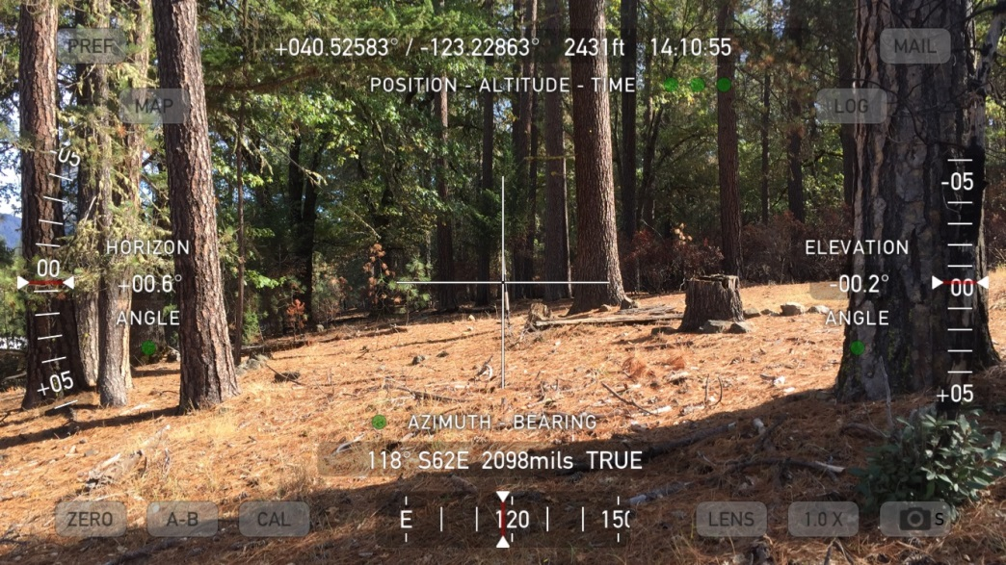
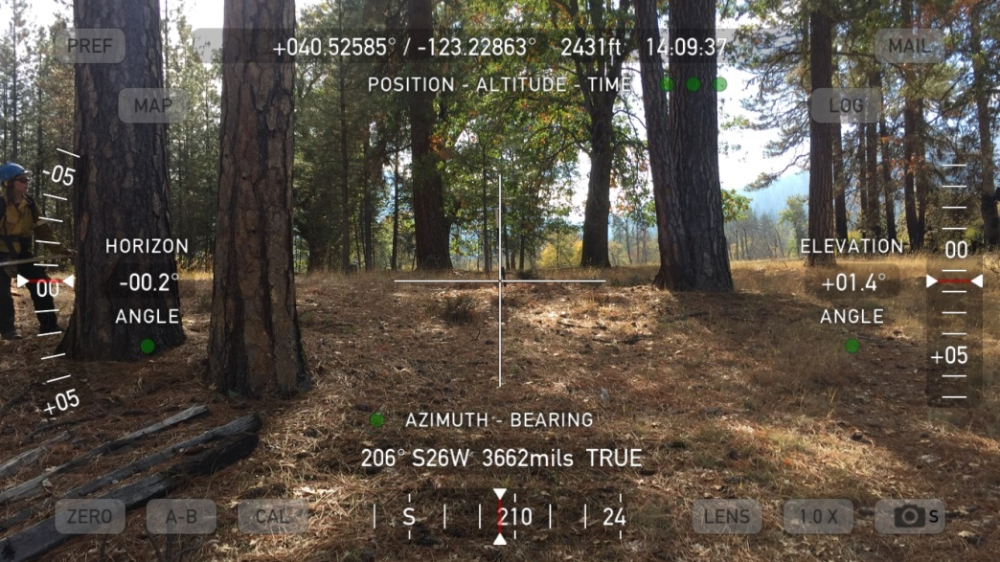
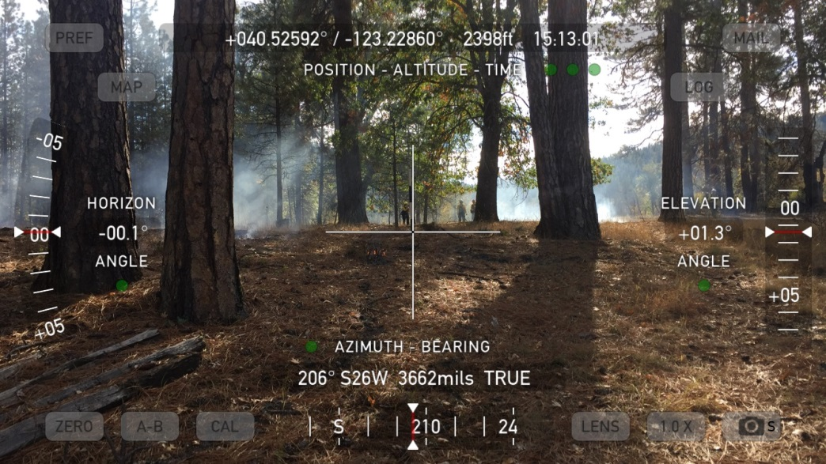
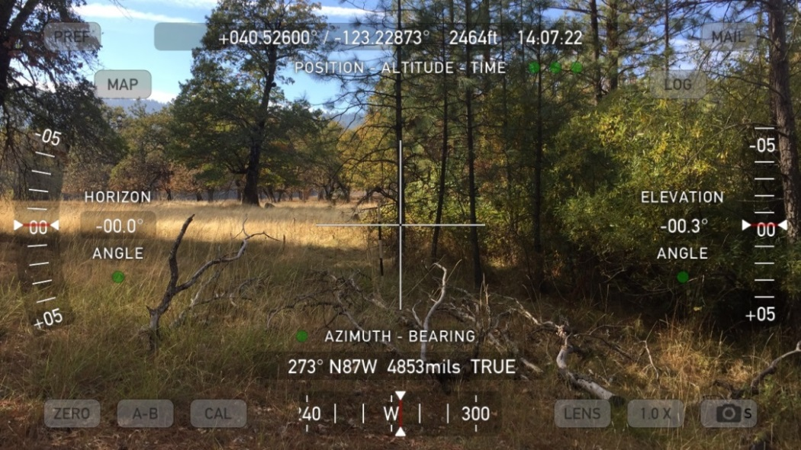
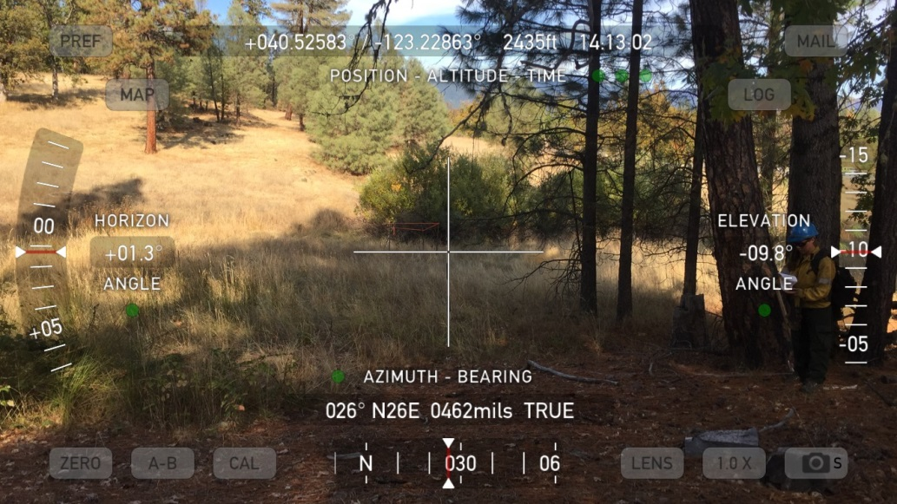
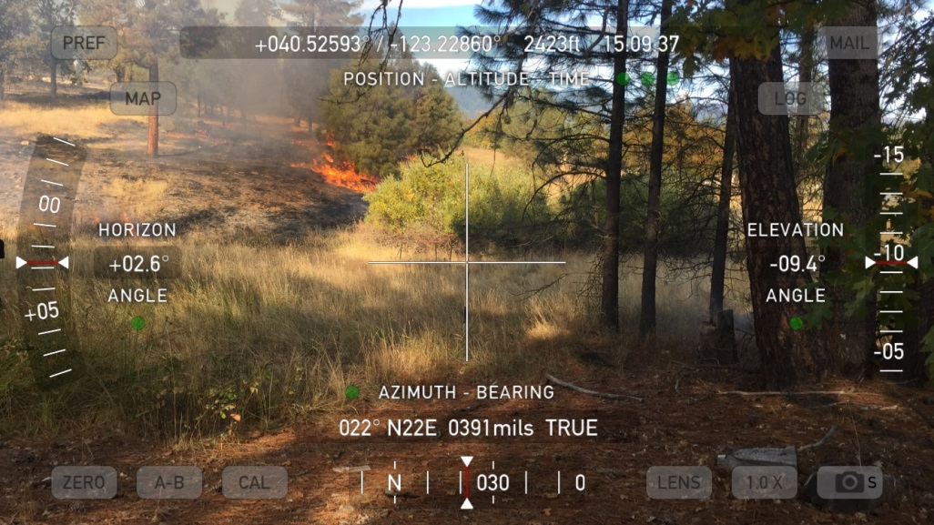
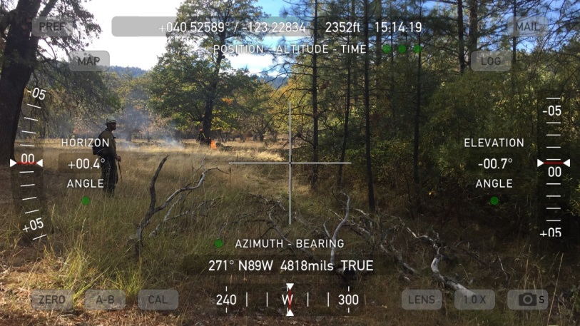
Pre-fire Post-fire
Pre-fire During-fire

